



**SM6P07NI Digital Media Project**

**50% Project**

**2024-25 Autumn**

**Student Name: Roman Shrestha**

**London Met ID: 22067419**

**College ID: np01mm4a220095**

**External Supervisor: Aashra Maharjan**

**Internal Supervisor: Bijay Shakya**

**Assignment Due Date: Wednesday, May 7, 2025**

**Assignment Submission Date: Wednesday, May 7, 2025**

**Word Count: 7482**

|  |  |
| --- | --- |
| **YouTube link** | [**https://youtu.be/PldIZYE5xhg**](https://youtu.be/PldIZYE5xhg) |
| **One Drive link** | [**DMP**](https://islingtoncollegeedunp-my.sharepoint.com/:f:/g/personal/np01mm4a220095_islingtoncollege_edu_np/EiEgKddGAcpEpaORzPeflM4BsWbeP-poqgYOEagY1C2OUw?e=1sHTsd) |
| **Git Hub link** | <https://github.com/Roman220095/Project-file> |

*I confirm that I understand my coursework needs to be submitted online via Google Classroom under the relevant module page before the deadline in order for my assignment to be accepted and marked. I am fully aware that late submissions will be treated as non-submission and a marks of zero will be awarded.*

Abstract

This documentation project includes all the process of animated awareness video of ‘Dengue’. It includes introduction, topic, area of research, finding client, aims of the project, target audience, product research, technologies employed project plan, pre-production, production, postproduction, resources, problem faced, user testing and findings, conclusion, references and appendix.

This document also provides an end-to-end description of the methods and procedures involved, including concept development, script writing, storyboarding, designing, editing, compositing, testing and rendering. The overall concept educational video was developed through supervisor and consumer fulfilments, personal perform and complete preparation to fit the requirement for the task to finalize the project. Hence, the final awareness animated video was piloted by using surveys & feedback offered by viewers to establish its authenticity.

**Contents**

1. Introduction 4

1.1 Topic 6

1.2 Area of Research 7

Animation in education 7

Health research 8

Understanding the clients 9

Targeting audiences 10

Motion graphics awareness storytelling 11

2. Finding client to client finalization 12

3. Aims of Project 13

4. Target Audience 14

5. Product Research 15

Videos research 15

Smoke effect 23

Lens blur effect 24

Audio research 25

6. Technologies Employed 26

• Fire Alpaca 26

• Adobe Illustrator 26

• Adobe After Effects 27

• Adobe Premier pro 27

• Toon boom 28

7. Project Plan 29

8. Production Phases 31

Pre-production 32

Concept 32

Script 33

Storyboard 36

Animatics 42

Production 43

Designing 43

Layout 44

Rigging 47

Animation 48

VFX 50

Rendering 51

Post-production 52

Editing and Compiling 52

Adding sound 53

Rendering 55

9. Resources 56

Software used 56

Hardware used 57

• Laptop 57

• Graphic tablet 57

Website used 57

10. Problem faced 58

11. User Testing & Findings 59

Survey results 59

12. Third party evaluation 64

Anush Shakya 64

Ranjan Adhikari 64

Kriza Limbu 64

13. Conclusion 65

14. References 66

16. Bibliography 68

17. Appendix 70

Gantt Chart 70

Approval letter 71

Log sheet 73

**Table of figures**

Figure 1 (alternative view studios, n.d.) 7

Figure 2 (austin visuals, n.d.) 8

Figure 3 (call center helper, n.d.) 9

Figure 4 (Patel, n.d.) 10

Figure 5 (Barker, n.d.) 11

Figure 6 15

Figure 7 16

Figure 8 17

Figure 9 18

Figure 10 19

Figure 11 20

Figure 12 21

Figure 13 22

Figure 14 23

Figure 15 24

Figure 16 (Pixabay, n.d.) 25

Figure 17 Fire Alpaca 26

Figure 18 Illustrator 26

Figure 19 After effects 27

Figure 20 Premier pro 27

Figure 21 Toon boom harmony 28

Figure 22 Project plan 1 29

Figure 23 project plan 2 29

Figure 24 (Toonz media group, n.d.) 31

Figure 25 Script 33

Figure 26 Script 1 34

Figure 27 Script 2 35

Figure 28 Animatic images 42

Figure 29 Animatics 42

Figure 30 Character 43

Figure 31Mosquito 43

Figure 32 44

Figure 33 45

Figure 34 45

Figure 35 46

Figure 36 mosquito rigging 47

Figure 37 character rigging 47

Figure 38 48

Figure 39 48

Figure 40 49

Figure 41 49

Figure 42 50

Figure 43 50

Figure 44 51

Figure 45 51

Figure 46 52

Figure 47 52

Figure 48 sound 53

Figure 49 sound 1 53

Figure 50 54

Figure 51 rendering 55

Figure 52 Software 56

Figure 53 (Gadgets house nepal, n.d.) 57

Figure 54 Websites 57

Figure 55 toonboom problem 58

Figure 60 59

Figure 61 59

Figure 62 60

Figure 63 60

Figure 64 61

Figure 65 61

Figure 66 62

Figure 67 62

Figure 68 63

Figure 69 63

Figure 56 Gantt chart 1 70

Figure 57 Gantt chart 2 70

Figure 58 college letter 71

Figure 59 client letter 72

Figure 70 Log sheet 1 73

Figure 71 Log sheet 2 74

Figure 72 Log sheet 3 75

Figure 73 Log sheet 4 76

Figure 74 Log sheet 5 77

Figure 75 Log sheet 6 78

Figure 76 Log sheet 7 79

Figure 77 Log sheet 8 80

Figure 78 Log sheet 9 81

Figure 79 Log sheet 10 82

Figure 80 Log sheet 11 83

Figure 81 Log sheet 12 84

Figure 82 Log sheet 13 85

Figure 83 Log sheet 14 86

Figure 84 Log sheet 15 87

Figure 85 Log sheet 16 88

Figure 86 Log sheet 17 89

Figure 87 Log sheet 18 90

Figure 88 Log sheet 19 91

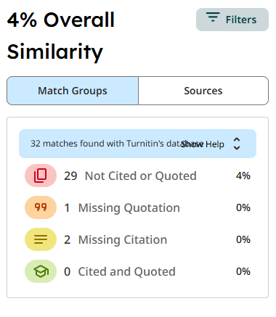

# Introduction

The Digital Media Project module's second coursework assignment contributes 50% to the final grade. The assigned project with its entire documentation system requires students to provide research findings and planning information and project objectives and technology details and production process documentation from pre-production through production and post-production. The process demands both user testing along with the compilation of proper evidence from findings. Students performed research to identify a client in the early phase of the coursework for their selected project. For my project, I selected the task of creating an awareness animated video for ward no. 11.

Throughout this coursework, each step from concept creation and planning to research and production has been covered in depth to create a good and visually pleasing animation video. This documentation is an attempt to clearly present the making of the project, the process, and its eventual implementation. It is a complete report of the process, from selecting the client, right through the process of making an animation. The overall objective is to present an in-depth picture of how the initial concept was turned into a fully completed awareness animated video.

This project is the final journey of digital media production. This is intended to create a well-crafted and message giving awareness animated video. The main purpose of this project is to develop an interesting awareness animated video to get the attention on the topic ‘Dengue’ to aware the people.

## Topic

**‘Dengue’**

This project video is created with a specific point on Ward 11, reaching out to the local community by tackling an urgent public health concern—dengue fever. The video is an educational resource to make residents aware of the risks of dengue, a viral disease spread by mosquitoes that still infects numerous individuals, particularly in densely populated or poorly informed communities. The subject mentions the disease mode of transmission—through a bite of the infected Aedes mosquito—and sets out typical manifestations such as elevated fever, severe headaches, rash, pains in the eyes located behind eyes, and musculature or articular pain.

The focus remains on protecting people from dengue through prevention efforts and fast medical reaction. The video uses attractive images along with helpful messages and specific local content to educate viewers about stopping dengue while also showing them what to do if they get infected. It shares easy self-treatment techniques while advising people to visit the doctor right away to prevent dengue complications.

Hence, by combining all the element like visual graphics, voice-over audios and background music with visually appealing animations, the final video focuses on creating awareness an engage the people in terms of preventing the disease dengue. Its main goal is to equip residents in Ward 11 with information to prevent disease spread and save lives.

## Area of Research

The major area of study has been finding out how to make a right animated awareness video for the dengue fever. Considering for each research I got information on how dengue spread, what are it signs, how one prevents of it, what all are the reason of dengue and why we just must cure of it. I also researched various animation techniques, methods and technologies to come up with the most practical way to convey information in an easy, clever and informative. This led to finalizing the final design, content and style of the awareness video.

The research concluded that the use of short, informative, and interesting animation is an effective method of stimulating public awareness and prevention of dengue, especially in the tropical and subtropical areas. (Muntasir, 2017)

### Animation in education



Figure 1 (alternative view studios, n.d.)

Students normally find it uninteresting and less captivating to read text. Although others may spend hours reading yet fail to comprehend the content or even memorize it into long-term memory, animations offer a faster and enjoyable way of learning. This mode of learning has the potential to enhance the attention and learning rates of students. (alternative view studios, n.d.)

### Health research



Figure 2 (austin visuals, n.d.)

Health research is an art and a science of studying the determinants and distribution of the health status of people as altered by social, economic, and physical environments, human biology, health policy, and services.

Medical research also provides methods and ways for disease prevention, the prolongation of life, and the preservation of health at the community levels through the enhancement of the efficiency and effectiveness of the health system as part of a general process of socio-economic development.

Health studies describe how people understand health and sickness and how they remain healthy and manage diseases. (Muntasir, 2017)

### Understanding the clients



Figure 3 (call center helper, n.d.)

To understand the client, I began with learning about the client's background and their services and objectives. I researched the audience demographics and message content along with preferred visual approaches of their organization. The production of the dengue awareness video for Ward 11 required me to understand how residents preferred to receive information and what health challenges they faced. I examined both the emotional approach and visual design elements that could appeal to the local audience.

### Targeting audiences



Figure 4 (Patel, n.d.)

The targeted viewers of this animated dengue education video reside in Ward 11 and consist mainly of families, students and working adults between the ages of 10 to 60 years old. Dengue has no gender bias because it impacts everyone including men and women throughout the world. The content delivery exists in basic terms which accommodates audiences from every educational background. The content presents basic information which suits people with different levels of education because it remains easy to understand. The chosen population falls under this category because direct awareness prevention methods prove most effective for high-risk groups. The video works to spread awareness throughout the local population to minimize the risks of both improper practices and future dengue spread.

### Motion graphics awareness storytelling

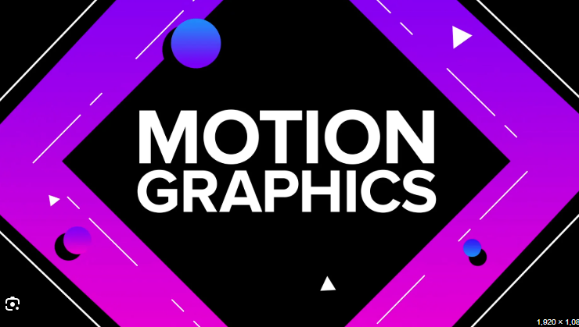

Figure 5 (Barker, n.d.)

The study aims at the process of creating a motion graphics animation awareness film, specifically how to create information that is informative as well as pleasing to the eye. It covers important areas like visual storytelling, pacing, typography, transitions, and the use of colours and sounds in conveying an understandable message. This research is applicable to a number of phases in the animation production process such as writing, design, and editing since it shows how one can restrict complex content and maintain audiences' interest. The research also offers the data needed for motion graphics to be translated for effectively communicating their message and stimulating awareness and action.

# Finding client to client finalization

At the very first step of find a client, with the help of college letter and through the contact with Bijay sir, I approached National Public Health Laboratory, Nepal but after some days the letter was rejected.

So, after that I approached another client explained my project of awareness animated video about ‘Dengue’ after some days they called me and said they would love to help me in my project.

After the I took the letters provided by the college to ward no.11 and gave them a report and finished the legal procedure.

Then the production process of my Digital Media Project about awareness animated video about ‘Dengue’ started.

# Aims of Project

This project aim is to create a visually appealing and message giving animated video that aware the people about the disease known as dengue which explains its causes, symptoms, prevention, and importance of early treatment. The video will de-mystify health information in images so that individuals can recognize early warning signs, gain preventive behaviour, and make steps towards curtailing the disease spread. It is designed to be easy to understand, easily transmissible and effective, especially among youth and high-risk groups.

**Purpose of the Project:**

* To inform the masses about how dengue is spread and how to prevent it.
* Encourage behavioural change through simple, day-to-day practices, like getting rid of still water around them and using repellents.
* The message will be more relatable and accessible, particularly to youth and their families, in catchy animation format that breaks down medical information.
* To support public health initiatives, by supplementing campaigns from the health departments and NGOs.
* To reach wider audiences through visual animation about awareness animated video.

**Why It Will Be Useful:**

* Visual learning works: Animate videos attract and recall better than text, especially among children and gives meaningful information.
* Accessibility: Video can be easily shared via schools, community groups, and social media.
* Language-free potential: Visual communication allows easier adaptation geographically with different languages.
* Battle misinformation: It provides short, fact-checked messages that fight dengue myths, encouraging right medical action.
* Behavioural Effect: There is an effect of long-term behaviour in repeated exposure to the video—like having clean houses or showing early signs of dengue. Animation has psychological and emotional impact that makes audiences care and do something about it.

# Target Audience

This awareness animated video is created to aimed at educating the public about dengue fever, its causes, symptoms, and prevention in an engaging and easy-to-understand manner. The target is to amplify the awareness among the masses, especially active and vulnerable members of society, to prompt early intervention and preventive activities to curb the spread of the disease.

**Age: 10 – 60 years old**

* Adolescents and children (10–18) are at highest risk because they are outdoors a lot, especially in the morning and evening when Aedes mosquitoes are most active.
* Young adults (19–40) are most likely to be active, mobile, and active online.
* Older adults (60 and under) may be family caregivers or decision-makers at the family and community levels, and therefore vital for spreading information and preventive behaviour.

**Gender: All genders**

* Dengue does not recognize gender. Awareness needs to percolate down to everyone so that prevention, a community task, can be achieved—swabbing homes, spraying repellents, early treatment.
* Engage both genders to be able to impart the message and reach the caregivers and the victims as well.

**Ethnicity: No specific ethnicity**

* Dengue does not differentiate between individuals based on ethnicity. By making the content culturally neutral or flexible, it makes sure that it can be utilized in multi-ethnic regions, particularly diverse countries.
* Localizing characters or language within the animation can make the video more accessible in some regions.

**Location: Urban and semi-urban areas**

* These areas are climatically suitable to have high prevalence of dengue (i.e., still water, favourable temperatures).
* Those who live in urban settings are at higher risk due to population, water storage practices, and the piling up of wastes common mosquito breeding places.

# Product Research

## Videos research

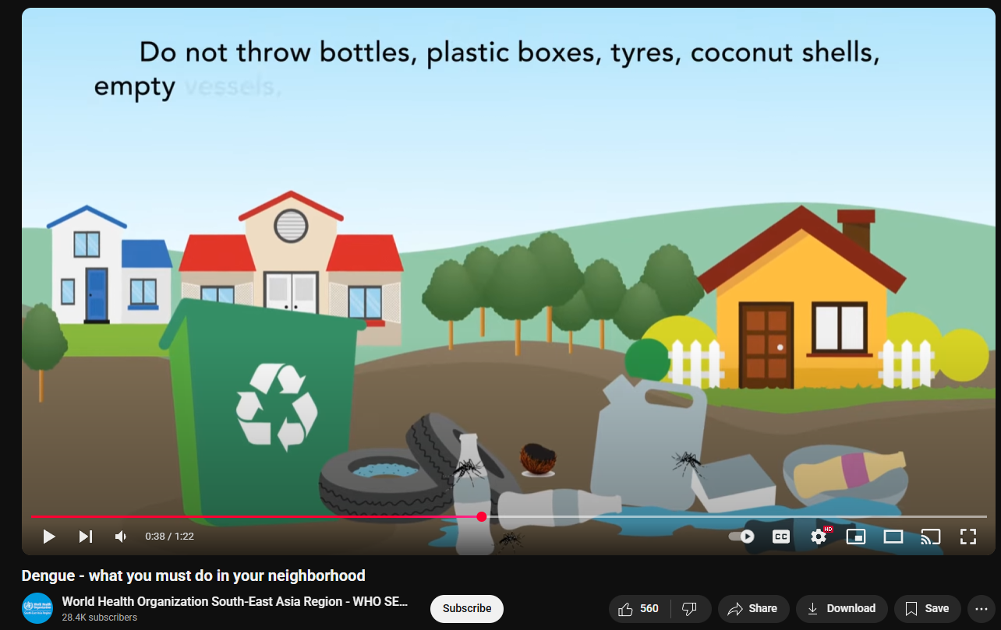

Figure 6

<https://www.youtube.com/watch?v=Fixp7OAYFfA&ab_channel=WorldHealthOrganizationSouth-EastAsiaRegion-WHOSEARO>

WHO SEARO's animation movie targets preventive activities in the community to control dengue disease. The video emphasizes proper elimination of places where mosquitoes like to breed such as standing water in containers, flowerpots, and trash tires. The video recommends avoiding mosquito breeding sites by cleaning up water storage drums frequently and correctly disposing of waste. These measures can effectively keep communities at minimal risk of being infected with dengue disease.

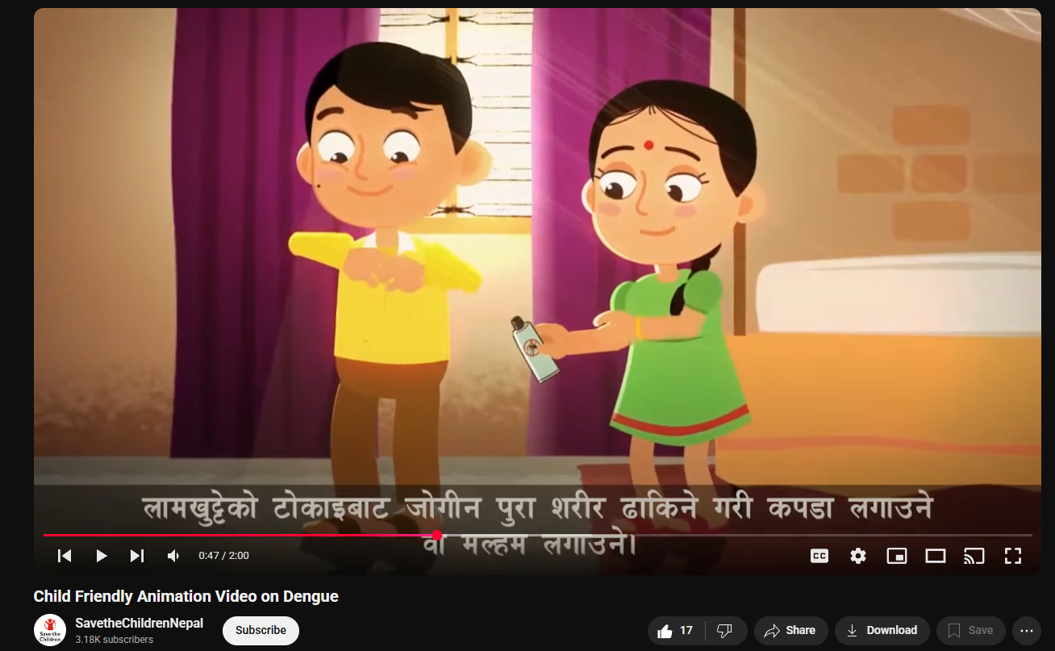

Figure 7

<https://www.youtube.com/watch?v=eyFyQcgOFp0&list=LL&index=6&ab_channel=SavetheChildrenNepal>

This Save the Children Nepal animated film aims to educate people about dengue disease. It deals with the cause of the disease, its symptoms, and the actions of prevention. The film draws attention to how one can prevent the environment from becoming dirty, avoid the standing water areas, and use the preventive options of mosquito nets and repellents in order to limit the breeding and bites of mosquitoes. The realistic visuals of the video and the simple narration aim to create awareness and inspire action to stop the spread of dengue among the masses.

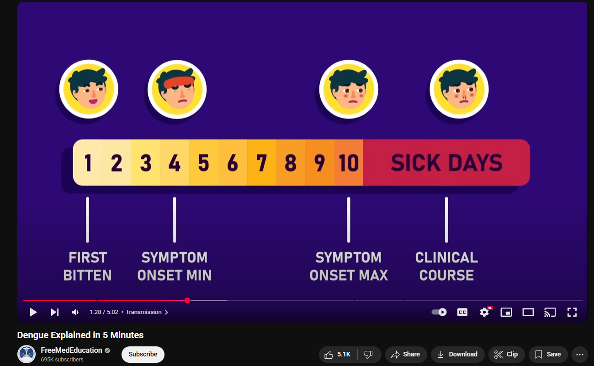

Figure 8

<https://www.youtube.com/watch?v=Ai9VZRIUN94&t=167s&ab_channel=FreeMedEducation>

The video was remarkable due to its incredible work on After Effects animation, which presented the content with a professional and polished touch. The motion graphics were perfectly adjusted to its story telling flowing with the story making it more informative and message giving video. This demonstrated the full capacity of animation, when paired with well thought out sound storytelling, to grab the attention of the people and convey the message.

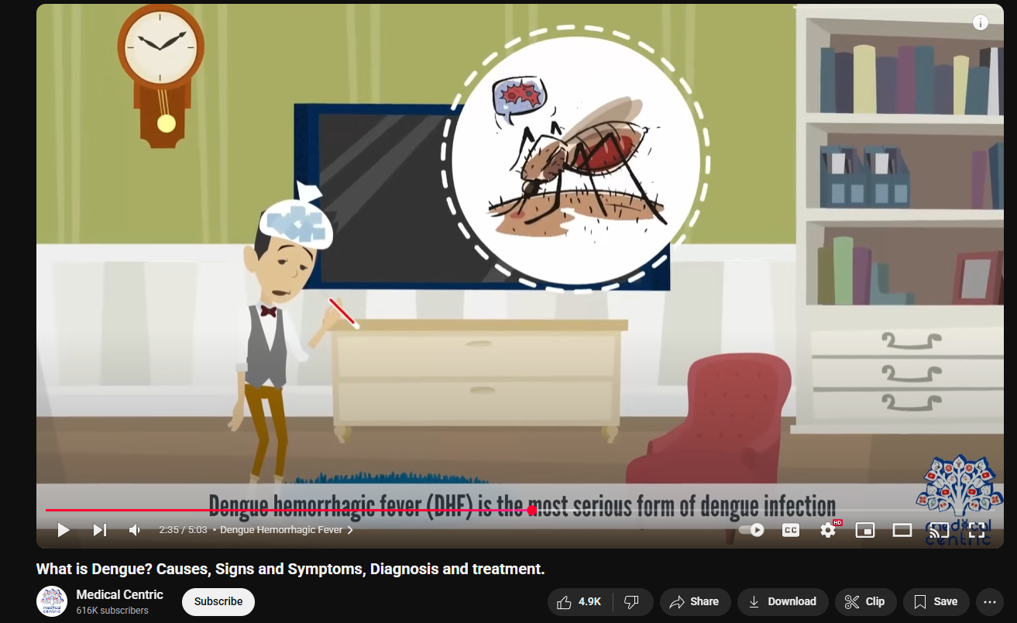

Figure 9

<https://www.youtube.com/watch?v=HAkYOOhbwos&ab_channel=MedicalCentric>

‘Medical centric – What is dengue’ video provides an extremely in-depth description that includes all the key points of the topic in a brief yet detailed manner. It explains the Fever and some serious infection in dept caused by dengue. Not only the basics but also examine each and every point making it more interesting and easily understandable with informative video.

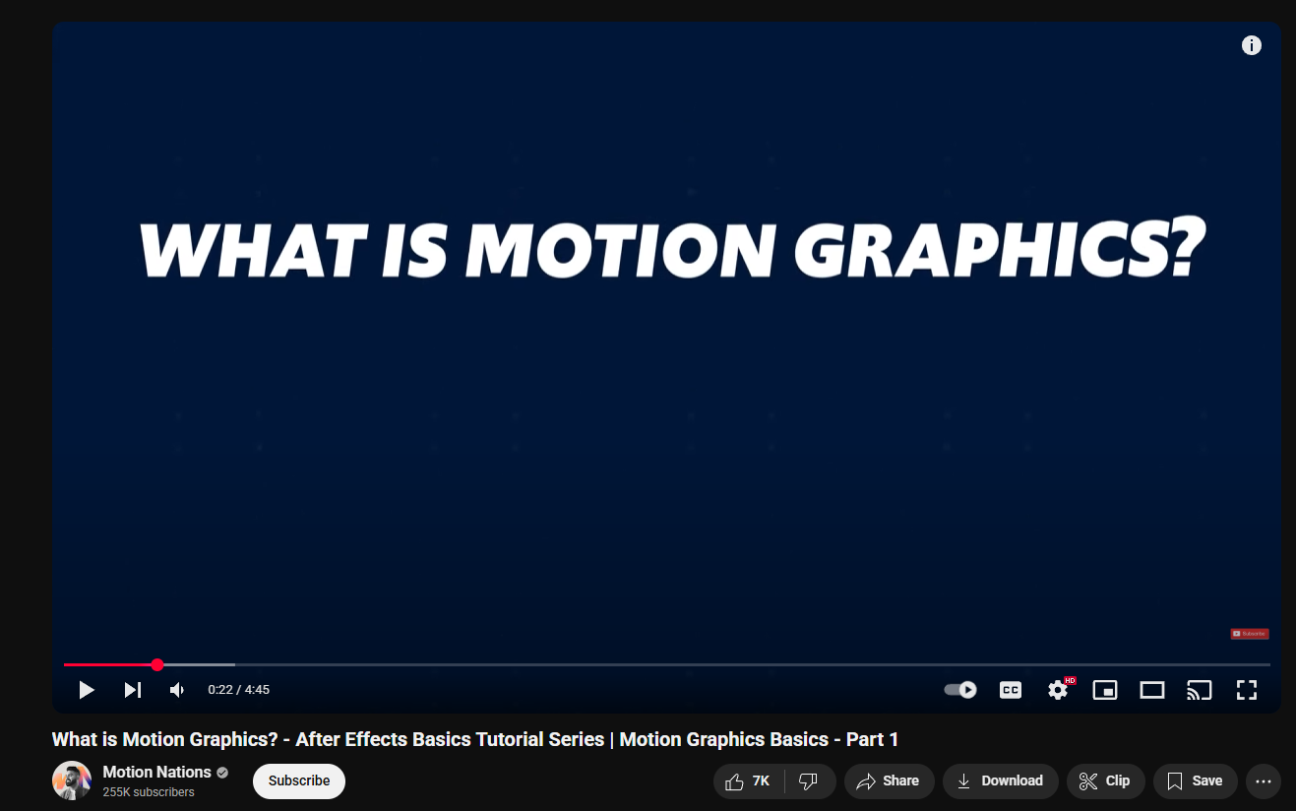

Figure 10

<https://www.youtube.com/watch?v=Hksg2s3gF6s&ab_channel=MotionNations>

The video "What is Motion Graphics? - "After Effects Basics Tutorial Series - Part 1" brought to you by Motion Nations teach you how to work motion graphics. It describes how motion graphics combine animation and graphic design to get message or information across. The video explains everyday use of motion graphics in the areas like commercials, explainer videos and in the digital interfaces. It also provides an introduction for the beginner to how to get started with creating motion graphics in Adobe After Effects and is a helpful stepping off point for someone who is just starting out.

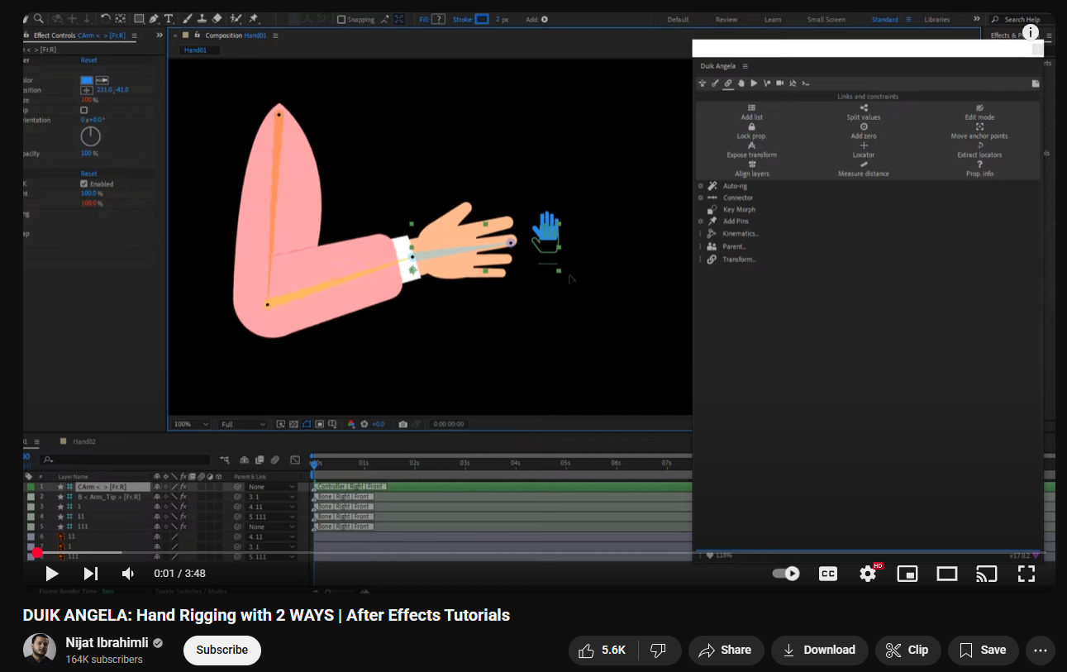

Figure 11

<https://www.youtube.com/watch?v=JLzEg3J2SEs&ab_channel=NijatIbrahimli>

Nijat Ibrahimli's video "DUIK ANGELA: In this video tutorial the creator shows you how to correctly rig hands in After Effects using the DUIK Angela plugin. The video helps people pick from two different hand rigging options they need for their projects. This tutorial will introduce rigging to newcomers step-by-step to help them understand everything needed in the process. This lesson provides essential tips to motion designers that make their character manipulation movements appear more realistic.

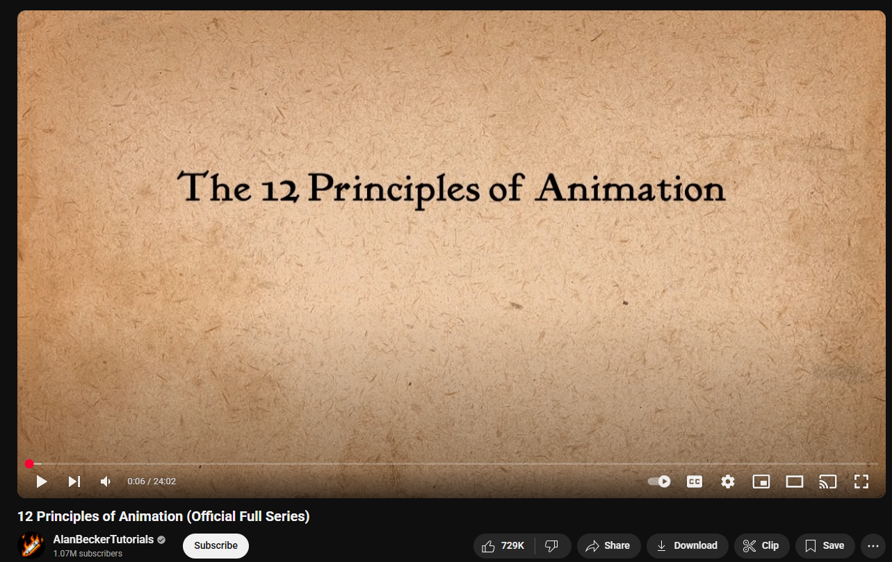

Figure 12

<https://www.youtube.com/watch?v=uDqjIdI4bF4&t=4s&ab_channel=AlanBeckerTutorials>

Alan Becker's instructional video "12 Principles of Animation (Official Full Series)" shows how to apply these basic animation techniques to produce real-life looking animations. In his video Alan Becker presents all 12 animation principles including Squash and Stretch for changing an object's weight and flexibility and Anticipation to show what's coming next. This training covers how to use Staging to direct viewers' attention, plus Straight Ahead Action and Pose to Pose as movement tools and Follow Through and Overlapping Action to extend movements beyond their start point. The video demonstrates how to use Slow In and Slow Out for transitional movement smoothness as well as shows how Arcs create natural movement paths, Secondary Action fortifies main action, and Timing controls how fast movements occur. Addictive motions become expressive because of exaggerations while learning Solid Drawing helps students understand three-dimensional forms. Appeal means creating characters that will keep the audience involved. The video gives useful animation knowledge to novices and professionals through direct teaching and real-world examples.

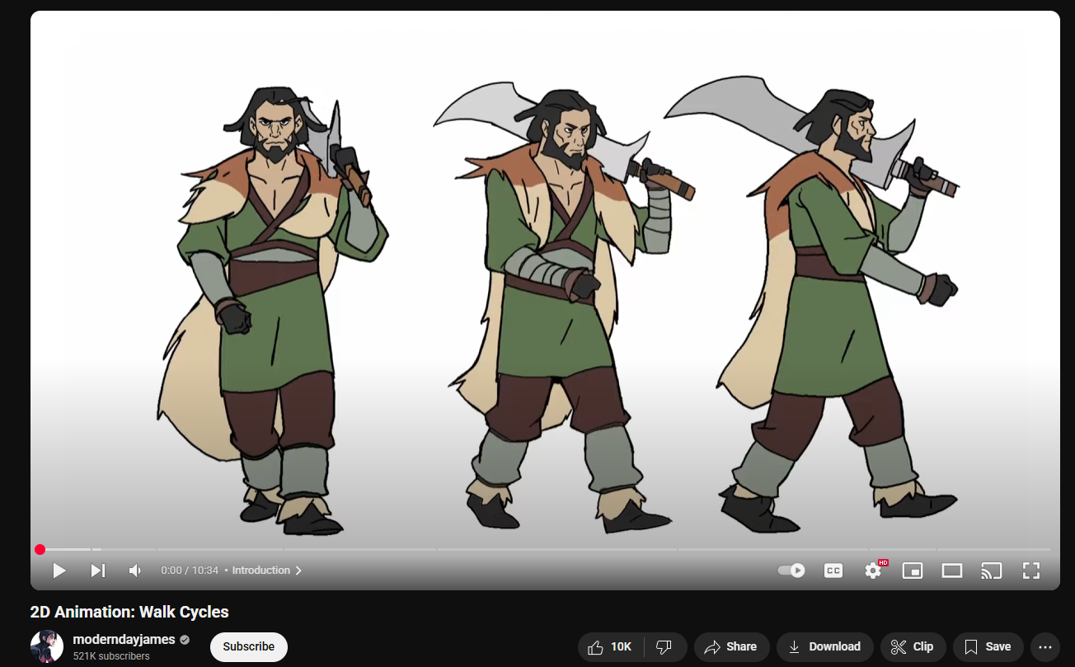

Figure 13

<https://www.youtube.com/watch?v=IViMJyqU9gY&ab_channel=moderndayjames>

The video titled "2D Animation: Assisting artists ModernDayJames teaches how to design realistic walk cycles in two-dimensional animation through a complete learning process. Through his walkthrough James teaches students how to reproduce natural footwork animation results. He teaches you how to create accurate walk cycles by showing you how to divide the process into small steps and explains what affects your character's natural walking motion. Our tutorial works well for beginners and experienced animators who both learn specific 2D character animation methods.

## Smoke effect

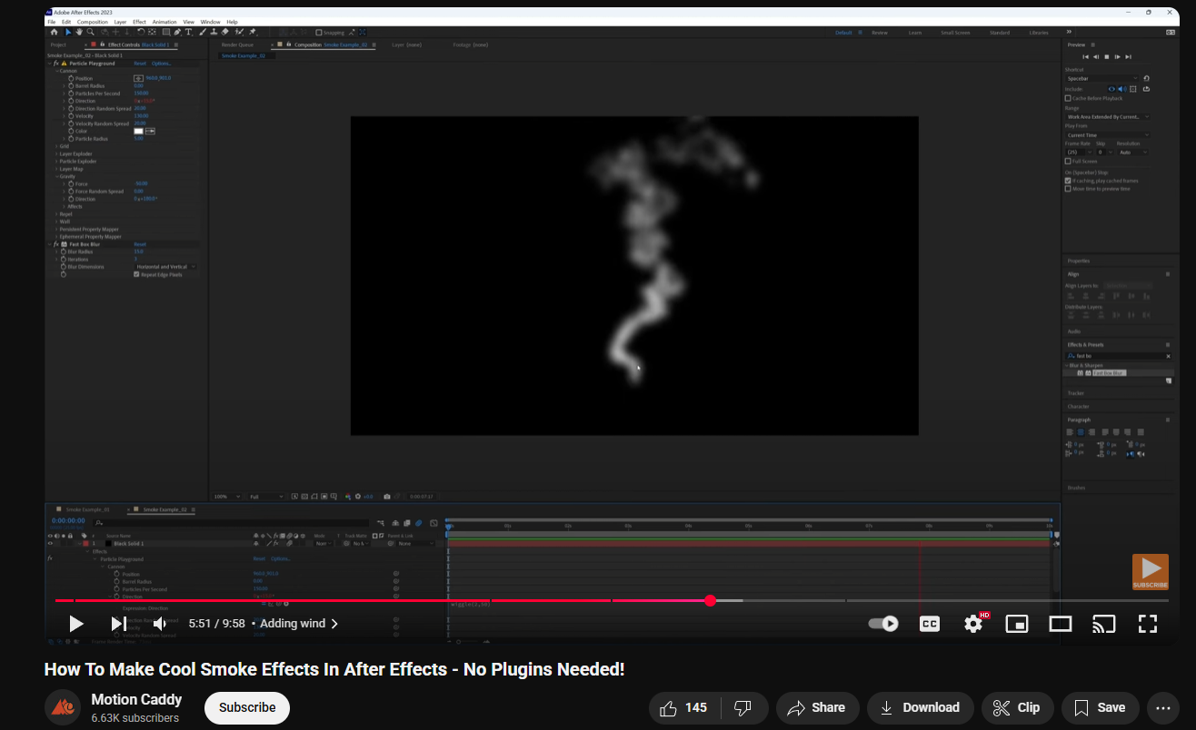

Figure 14

<https://www.youtube.com/watch?v=Pv3aQzuJjIo&ab_channel=MotionCaddy>

The tutorial video illustrates how to create a realistic smoke effect in After Effects' Particle Playground. It explains how to alter emitter settings, particle size, colour, and motion to create the illusion of real smoke. It also uses effects like blur and turbulence to enhance the realism.

## Lens blur effect

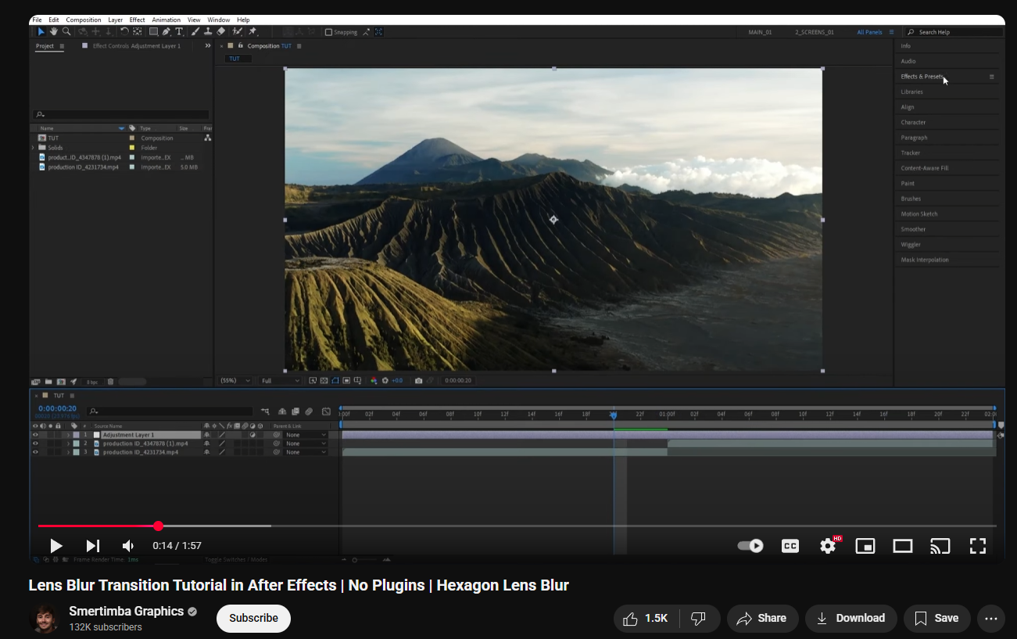

Figure 15

<https://www.youtube.com/watch?v=rMaX9h6kvzY&ab_channel=SmertimbaGraphics>

Smertimba Graphics' tutorial video "Lens Blur Transition Tutorial in After Effects | No Plugins" guides you step by step on how to create a film-grade lens blur transition effect solely using only the internal capabilities of Adobe After Effects without relying on any third-party plugin. The tutorial is kept simple and easy to follow, hence suitable for beginners and expert editors as well. This video helps in making the background blur and focusing on the main object. Most effects are done in after effects.

## Audio research

The audio part is the most important part of any videos in terms of film making and animation. The sound effect makes the video more effective and maintains the viewer’s attention. Also, the background sound effects, music and voice-over add ambience with meaningful information and gives relevant messages. Good audio also assists with accessibility so that anyone of any age and literacy level can comprehend the message easily.

So, for this animation video, sound elements like morning and evening noises, mosquito buzzing, and background music were studied extensively to enhance each scene. The sound effects enhance the video by contributing realistic sounds settings. Background music also underscores tone, providing depth and interest and emotion to the video.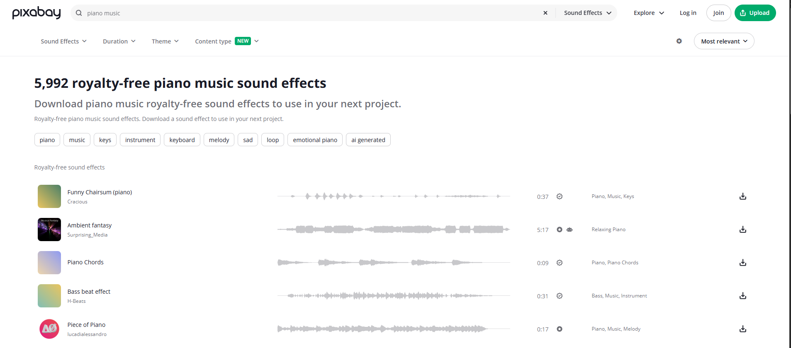

Figure 16 (Pixabay, n.d.)

# Technologies Employed

## Fire Alpaca

Fire Alpaca presents itself as a free digital painting software which delivers both simplicity and exceptional performance. The software features components that match the features of Adobe Photoshop and Illustrator and CorelDRAW. Fire Alpaca successfully runs since 2011 because developers perform continuous updates to improve the program. The software operates with features such as layers together with custom brushes and perspective guide capabilities. Both novice and professional digital artists should find this software to be an excellent solution. (helyer, 2023)



Figure 17 Fire Alpaca

## Adobe Illustrator

Adobe Illustrator introduced in 1987 has become a top-software platform for designing vector graphics. Illustrator from Adobe delivers innovative features to help users develop designs for illustrations in addition to logos and icons along with typography and various artwork elements. Designers and artists throughout the Adobe Creative Cloud platform frequently use Illustrator for their personal as well as professional needs like branding and marketing content creation. The software serves as a fundamental tool in design projects due to its flexible and accurate functionality. (Mitchell, 2021)



Figure 18 Illustrator

## Adobe After Effects

The video animation and motion graphics and special effects creation software Adobe After Effects enables users to produce effects for YouTube content along with broadcast videos and marketing presentations. The software provides multimedia visual optimization tools that deliver enhanced content for multiple media platforms such as film and TV and websites along with in-store displays. After Effects remains the preferred software among video editorial agencies and visual design firms and advertising companies for producing outstanding visual effects. (alexander, 2023)



Figure 19 After effects

## Adobe Premier pro

Adobe Systems developed Premiere Pro which functions as a video editing solution designed to work on videos and commercials alongside television productions along with internet-based content. Users can edit audio through its built-in tools. Users can access Premiere Pro through its standalone version or as part of the complete Adobe Creative Cloud package. This tool functions with After Effects and Photoshop to handle complicated creative work. (Smith, 2024)



Figure 20 Premier pro

## Toon boom

The animation production software Toon Boom Harmony delivers advanced capabilities which visual creators use for their work on films as well as television shows, online series, commercials, video games and other projects. Through its cutting-edge engineering developers and studios achieve unrestricted creativity and numerous creative tools for animation development. (Harmony 20 Essentials, n.d.)



Figure 21 Toon boom harmony

# Project Plan

The original Gantt chart for the project was created during the 5th semester of planning. Production scheduling, though, had to be realigned due to some unexpected issues with the client as well as other issues. The revised Gantt chart (Image 2) depicts gigantic discrepancies from the initial plan (Image 1). One of the notable adjustments was in the background design work, which now starts later than it was originally planned and takes a shorter duration, with some portion of the work shifted towards the end of the schedule. The pre-production documentation phase was also minimized, which indicates improved planning and execution effectiveness. Also, the final post-production stage, "Rendering and Exporting," was moved to the later part to accommodate the delays in previous stages. All these delayed task lengths show how the project team readjusted the timeline to compensate for shifting project requirements.

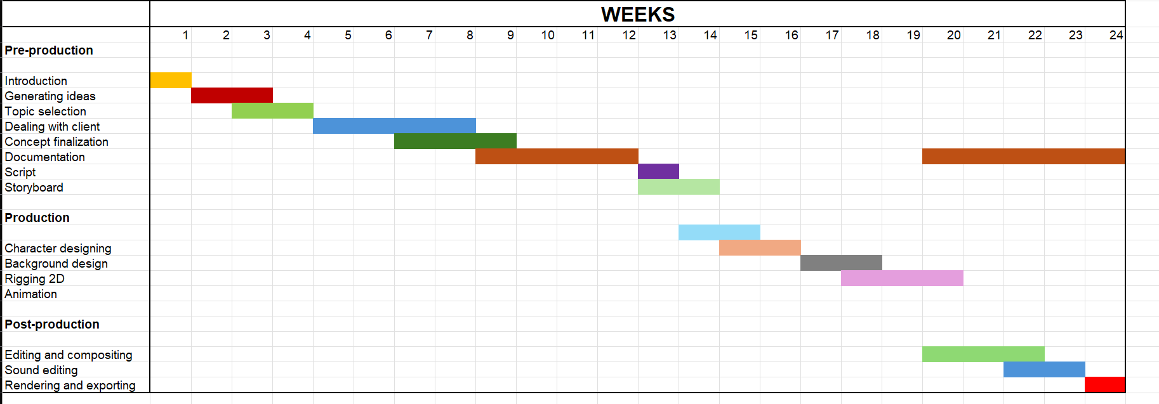

Figure 22 Project plan 1

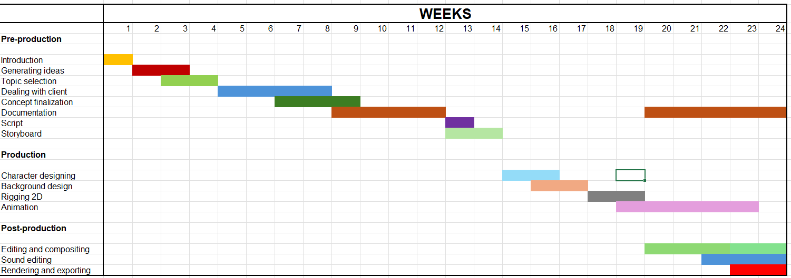

Figure 23 project plan 2

**Changes in the concept**

The original idea of the project was to build two characters in a single video to deliver the message more effectively through conversation and interaction. As the novel progressed, it became clear that two characters overwhelmed the narrative and broke up the flow of the message. In order to preserve clarity and emphasis on the awareness component of the video, the concept was altered. Therefore, one main character, a mosquito, was developed to embody the dengue cause. This change made the narrative simpler, consolidating it into a shorter and more impactful story for viewers.

# Production Phases

The animation production sequence includes three fundamental phases starting with pre-production and continuing to production and finishing with post-production. A structured production pipeline allows the industry to handle efficient workflow and teamwork management. Analysis of the main processes required to produce animated content appears in this article.

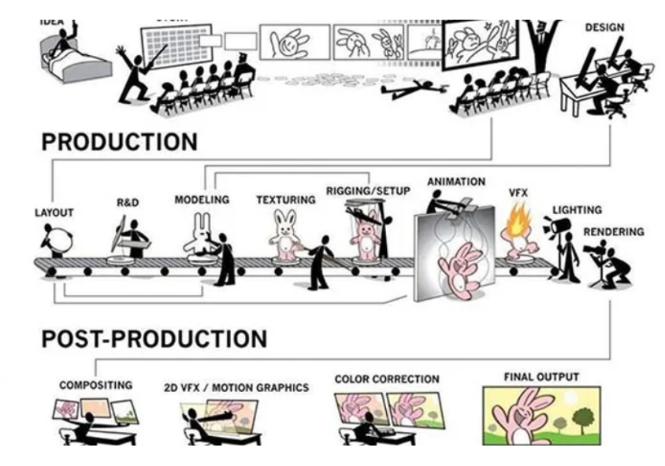

Figure 24 (Toonz media group, n.d.)

## Pre-production

### Concept

In a night of full moon and stars with moving clouds the mosquito comes and moves here and there looking for something. After that the mosquito find a house and enters inside through an open window then the mosquito sees a character and goes closer then bites it.

The sun rises with a morning house scene and the character wakes up having pimples in his body with some body pain with high fever. Then a text appears saying the ways of curing the disease. After that the remedies are shown,

Lastly, with the voice over if the prevention does not cure the disease, a hospital scene appears and the character heads to it focusing the hospital.

### Script

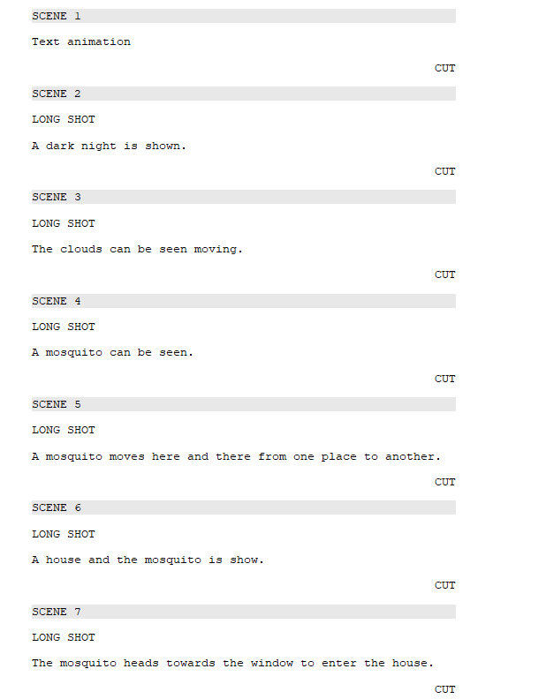

Figure 25 Script

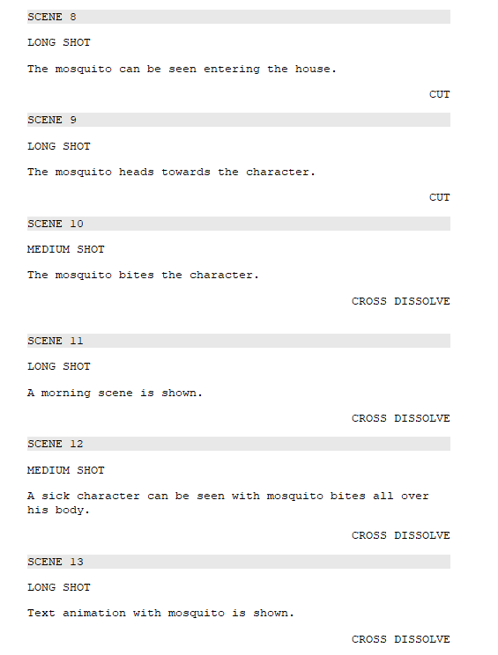

Figure 26 Script 1

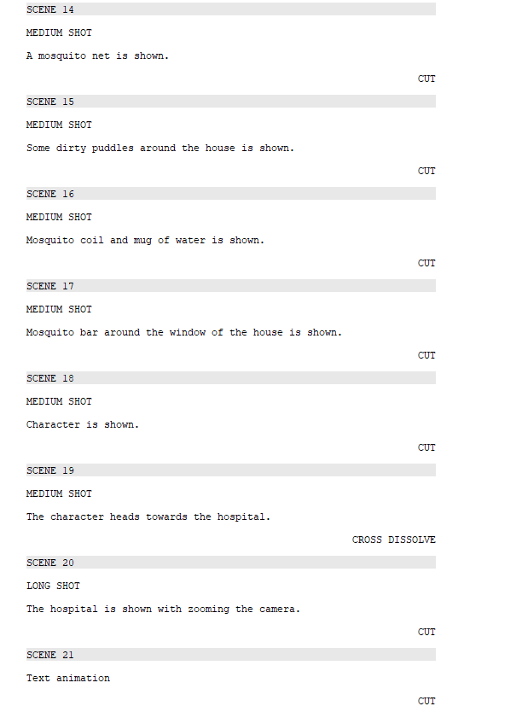

Figure 27 Script 2

### Storyboard

|  |  |  |  |  |  |
| --- | --- | --- | --- | --- | --- |
|  | |  | | --- | | Scene 1 | | Shot: Long shot | | Time: 3 sec | | Description: Text animation | |
|  | |  | | --- | | Scene 2 | | Shot: Long shot | | Time: 2 Sec | | Description: A dark night is shown. | |
|  | |  | | --- | | Scene 3 | | Shot: Long shot | | Time: 2 Sec | | Description: The clouds can be seen moving. | |
|  | |  | | --- | | Scene 4 | | Shot: Long shot | | Time: 2 Sec | | Description: A mosquito can be seen. | |
|  | |  | | --- | | Scene 5 | | Shot: Long shot | | Time: 2 Sec | | Description: A mosquito moves here and there from one place to another. | |
|  | |  | | --- | | Scene 6 | | Shot: Long shot | | Time: 3 Sec | | Description: A house and the mosquito is show. | |
|  | |  | | --- | | Scene 7 | | Shot: Long shot | | Time: 2 Sec | | Description: The mosquito heads towards the window to enter the house. | |
|  | |  | | --- | | Scene 8 | | Shot: Long shot | | Time: 2 Sec | | Description: The mosquito can be seen entering the house. | |
|  | |  | | --- | | Scene 9 | | Shot: Long shot | | Time: 4 sec | | Description: The mosquito heads towards the character. | |
|  | |  | | --- | | Scene 10 | | Shot: Medium shot | | Time: 3 sec | | Description: The mosquito bites the character. | |
|  |  |
|  | |  | | --- | | Scene 11 | | Shot: Long shot | | Time: 3 sec | | Description: A morning scene is shown. | |
|  | |  | | --- | | Scene 12 | | Shot: Medium shot | | Time: 11 sec | | Description: A sick character can be seen with mosquito bites all over his body. | |
|  | |  | | --- | | Scene 13 | | Shot: Long shot | | Time: 5 sec | | Description: Text animation with mosquito is shown. | |
|  | |  | | --- | | Scene 14 | | Shot: Medium shot | | Time: 6 sec | | Description: A mosquito net is shown. | |
|  | |  | | --- | | Scene 15 | | Shot: Medium shot | | Time: 5 sec | | Description: Some dirty puddles around the house is shown. | |
|  | |  | | --- | | Scene 16 | | Shot: Medium shot | | Time: 8 sec | | Description: Mosquito coil and mug of water is shown. | |
|  | |  | | --- | | Scene 17 | | Shot: Medium shot | | Time: 8 sec | | Description: Mosquito bar around the window of the house is shown. | |
|  | |  | | --- | | Scene 18 | | Shot: Medium shot | | Time: 5 sec | | Description: Character is shown. | |
|  | |  | | --- | | Scene 19 | | Shot: Medium shot | | Time: 5 sec | | Description: The character heads towards the hospital. | |
|  | |  | | --- | | Scene 20 | | Shot: Long shot | | Time: 5 sec | | Description: The hospital is shown with zooming the camera. | |
|  | |  | | --- | | Scene 21 | | Shot: Long shot | | Time: 3 Sec | | Description: Text animation | |

### Animatics

The first stage includes drawing a storyboard which maps out both animation sequence and visual design. Sketches or illustrations in the storyboard symbolize important scenes along with camera angles together with actions. After storyboard completion the design software exports images using the appropriate video editing format. Adobe Premiere Pro receives the images to build an animatic that functions as a basic animated version of the final product. Through the animatic process the storyboard images unite with a short temporary soundtrack to provide basic timing information that shows how the finished animation will progress. This step helps to finalizer the final animation easier and faster.

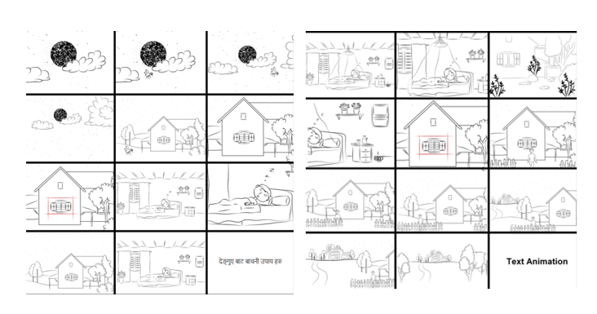

Figure 28 Animatic images

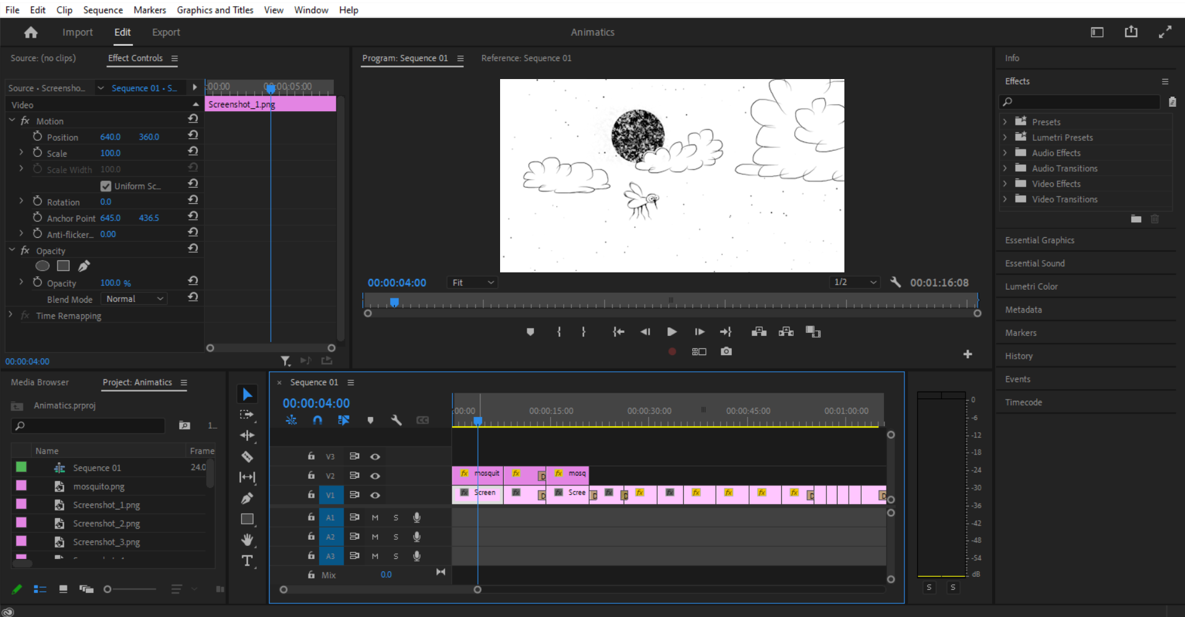

Figure 29 Animatics

## Production

### Designing

The character is created in Adobe Illustrator using pen tool and shape. Careful design and instant changes to the different elements, such as body, face, and limbs, allow for fluid and flexible animation at a future point in the production cycle.

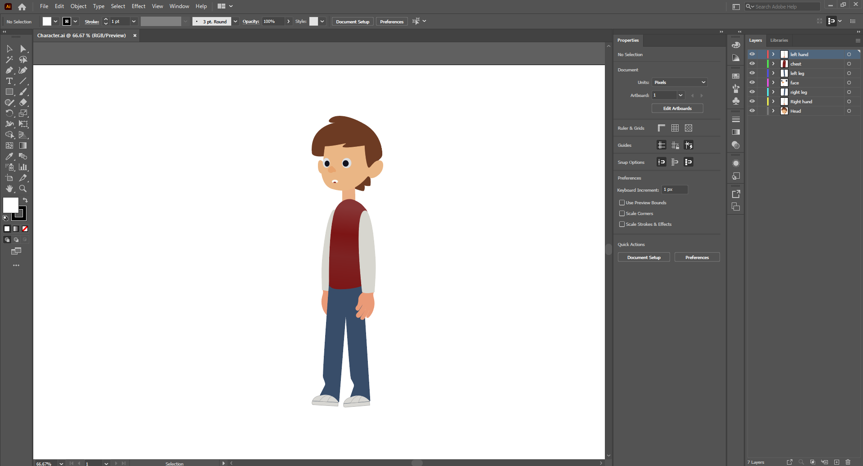

Figure 30 Character

Similarly, the mosquito too is designed in Illustrator with more focus on small details like wings, body, and legs. Being a vector-based design, the mosquito is easily resizable and animatable without losing its quality, which suits the video requirement of animation well.

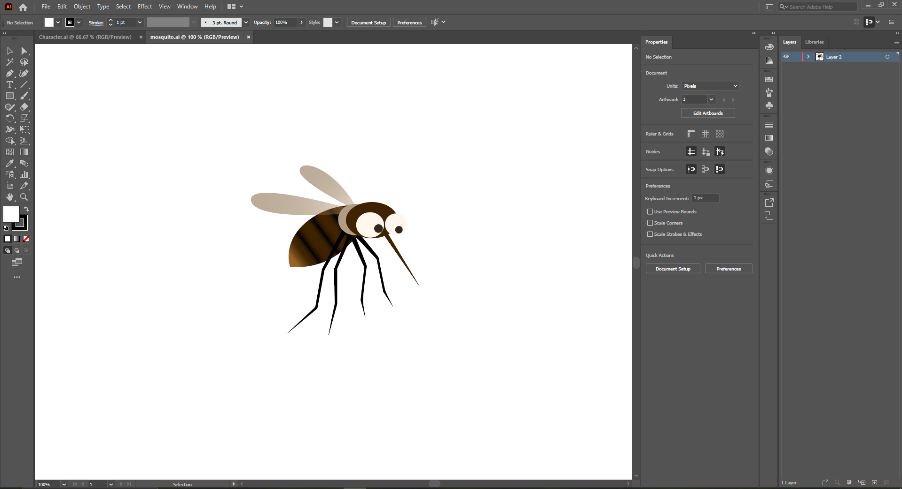

Figure 31Mosquito

### Layout

After the characters had been designed, the background scenes were designed using FireAlpaca with a graphics tablet. Each scene was colorized and given depth with various colours and brush tools. Every element, ranging from trees, houses, roads, to the sky, was drawn on individual layers so that later animation would be smoother and easier. This method provided smoother motion and animation control since assets were either changed or worked with without interrupting the complete scene. Having each piece of the art be done individually also helped in visual coherence and reduced post-production time.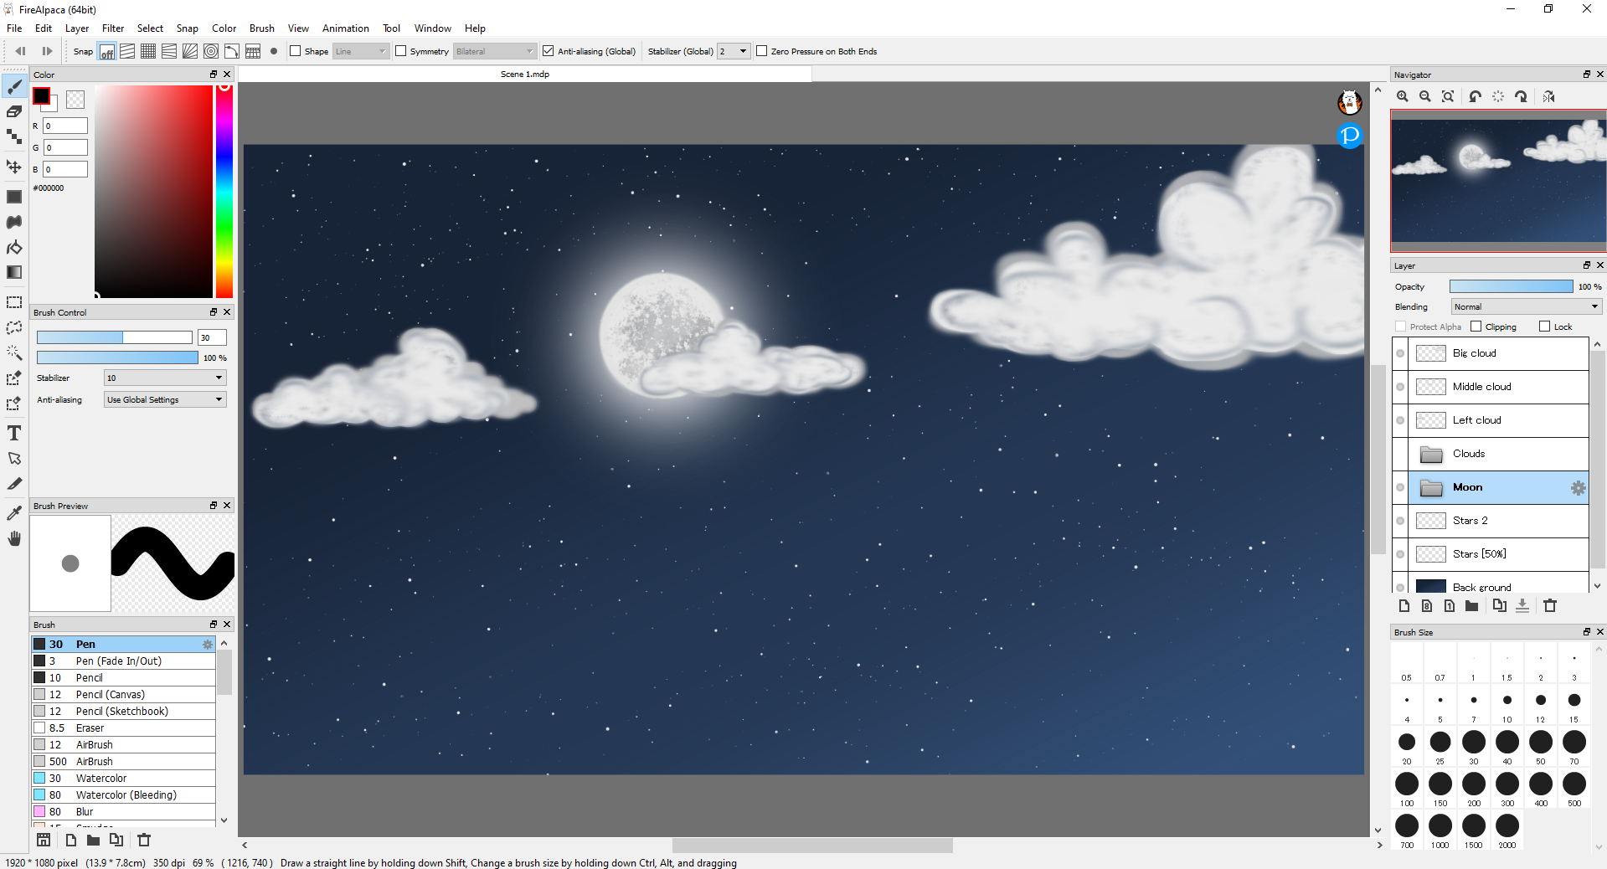

Figure 32

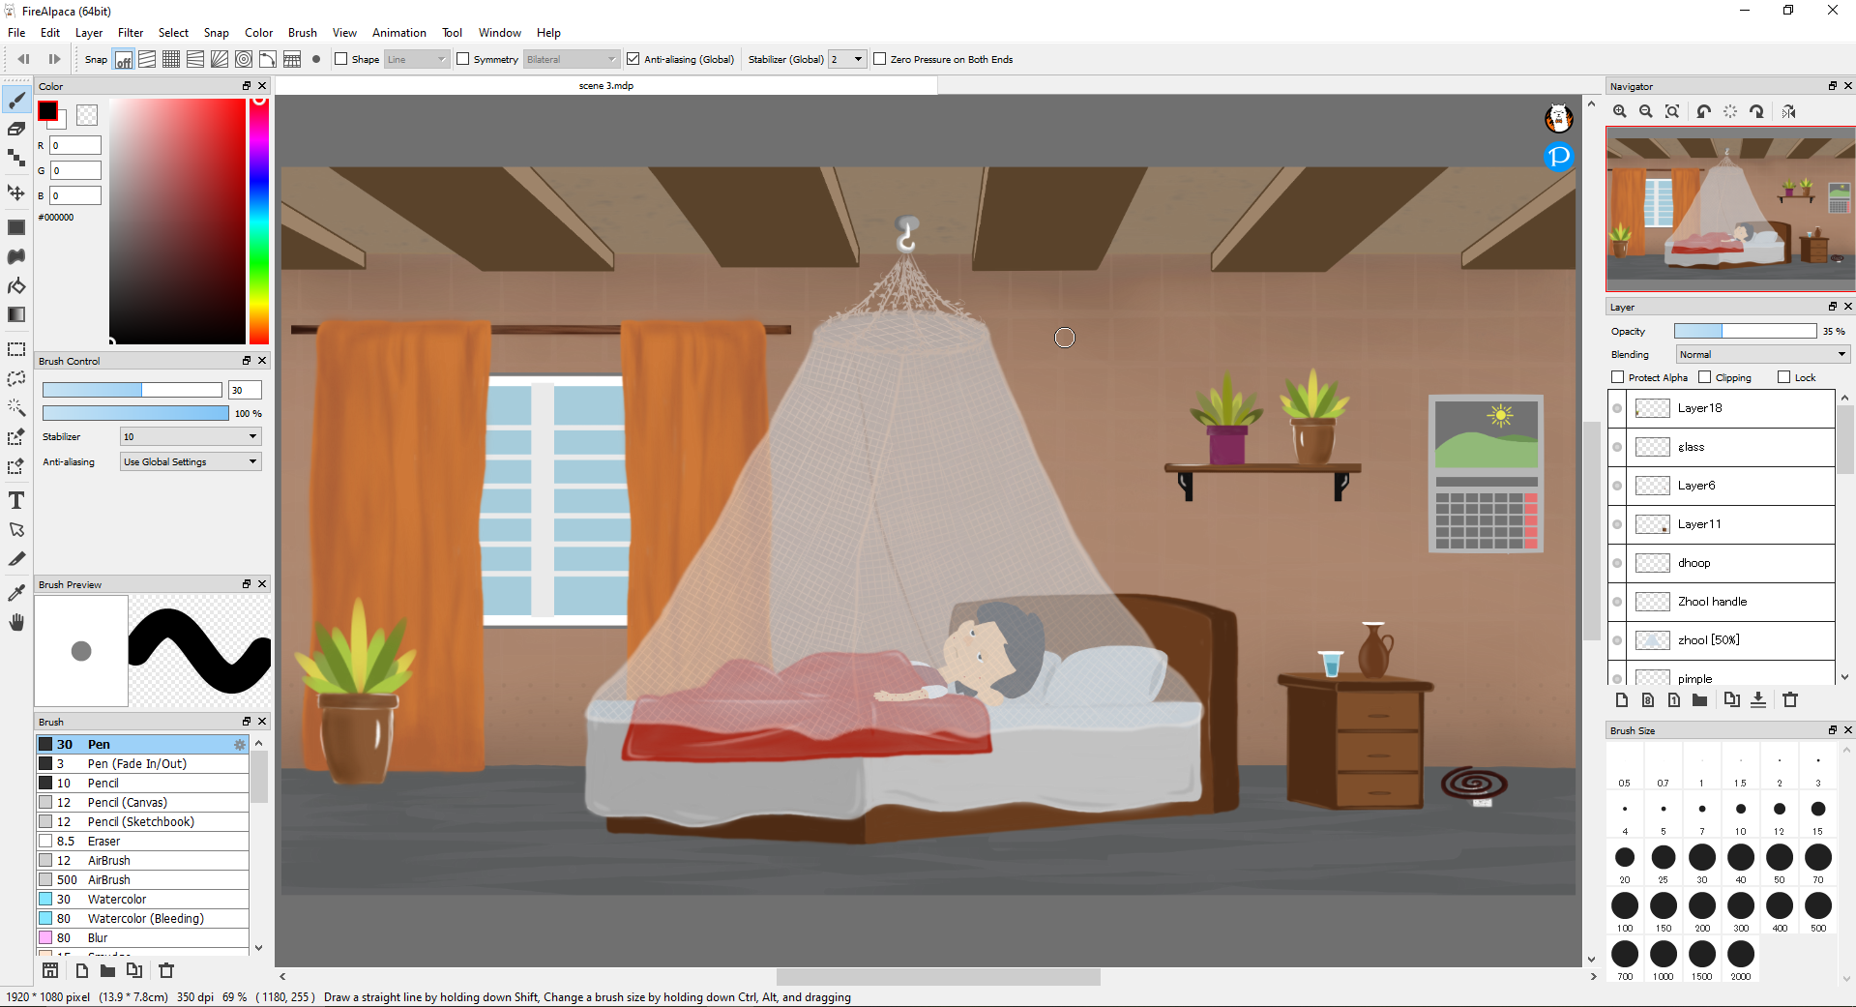

Figure 33

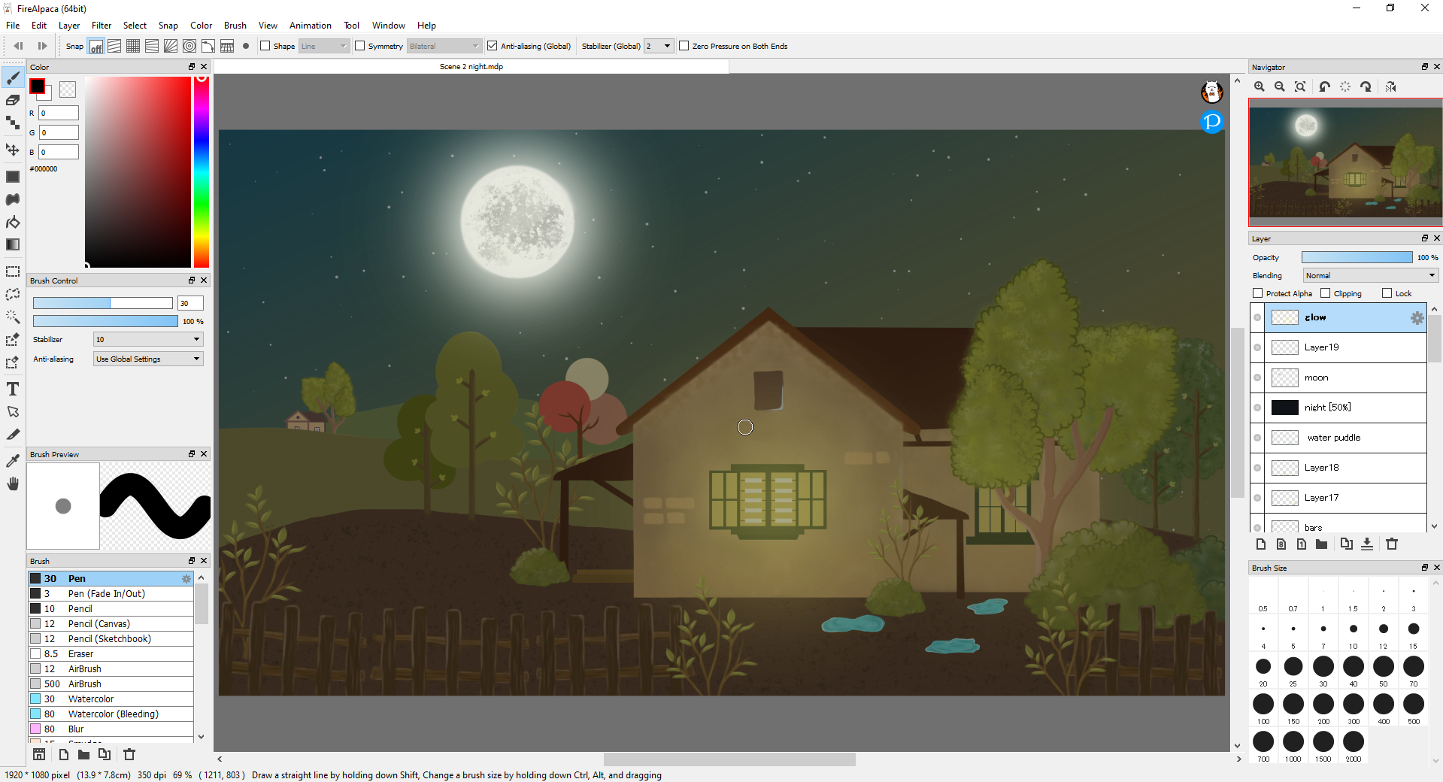

Figure 34

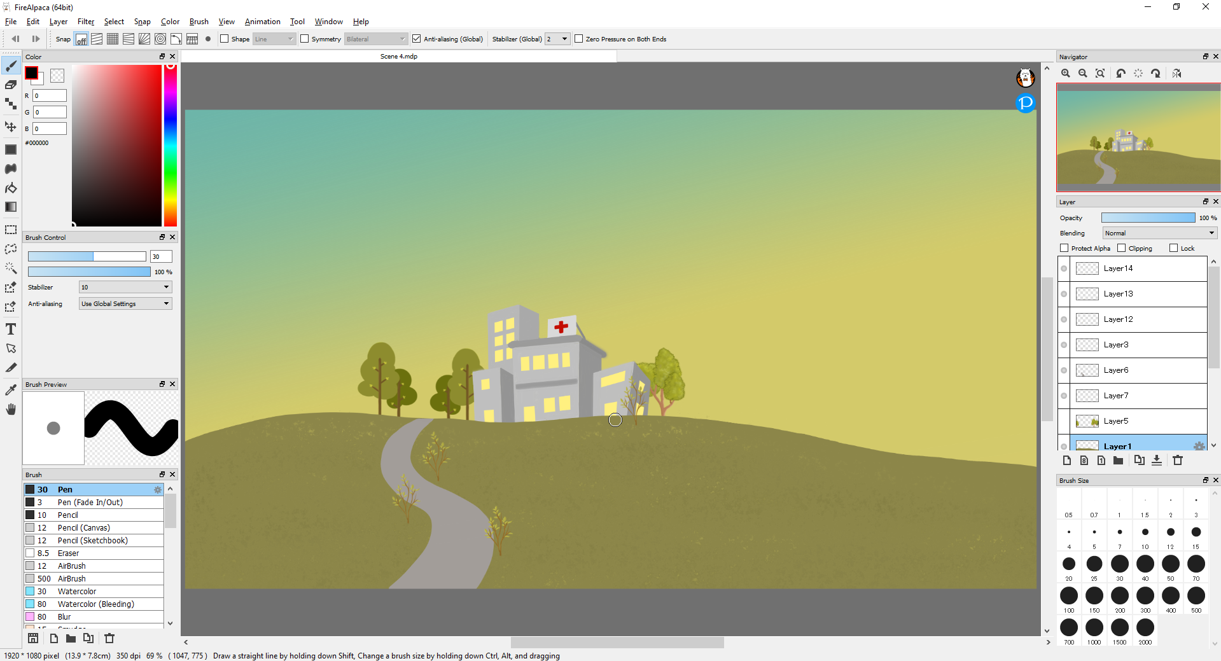

Figure 35

### Rigging

Arranging its layers the mosquito is exported from illustrator to toon boom harmony. After that the part of mosquito legs, wings and eyes are being rigged for further animation. After rigging the key frames are being set for mosquito. Its animation was also done in toon boom harmony and exported in alpha layers for further process.

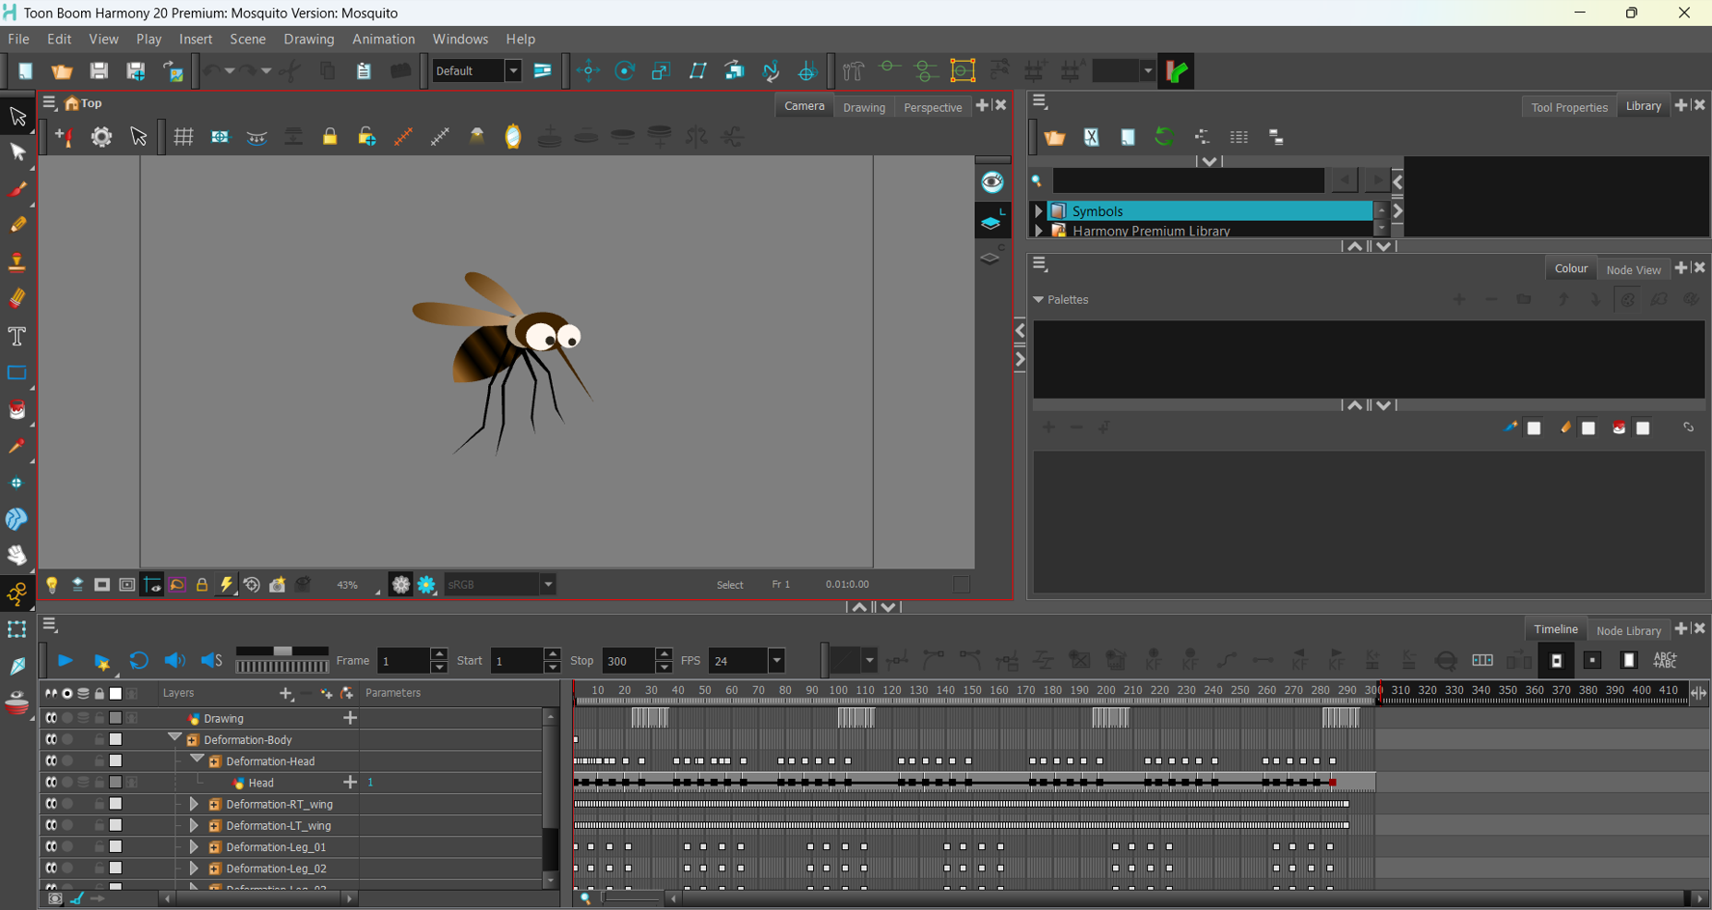

Figure 36 mosquito rigging

Similarly, as of mosquito the character walk cycle animation was done after rigging it. Setting its keyframes to its legs, hands, body, head and eyes blinks are animated and exported in alpha layers for further animating.

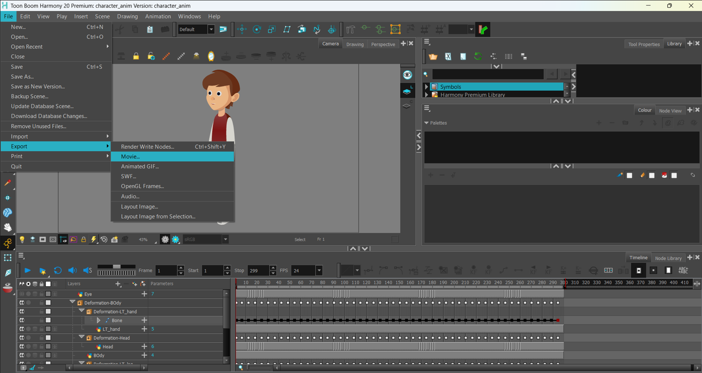

Figure 37 character rigging

### Animation

To animate the scene all the background images were exported from fire alpaca individually for animation process. After that the rigged mosquito was imported and its position, scale and orientation were animated then the background clouds position were also animated individually.

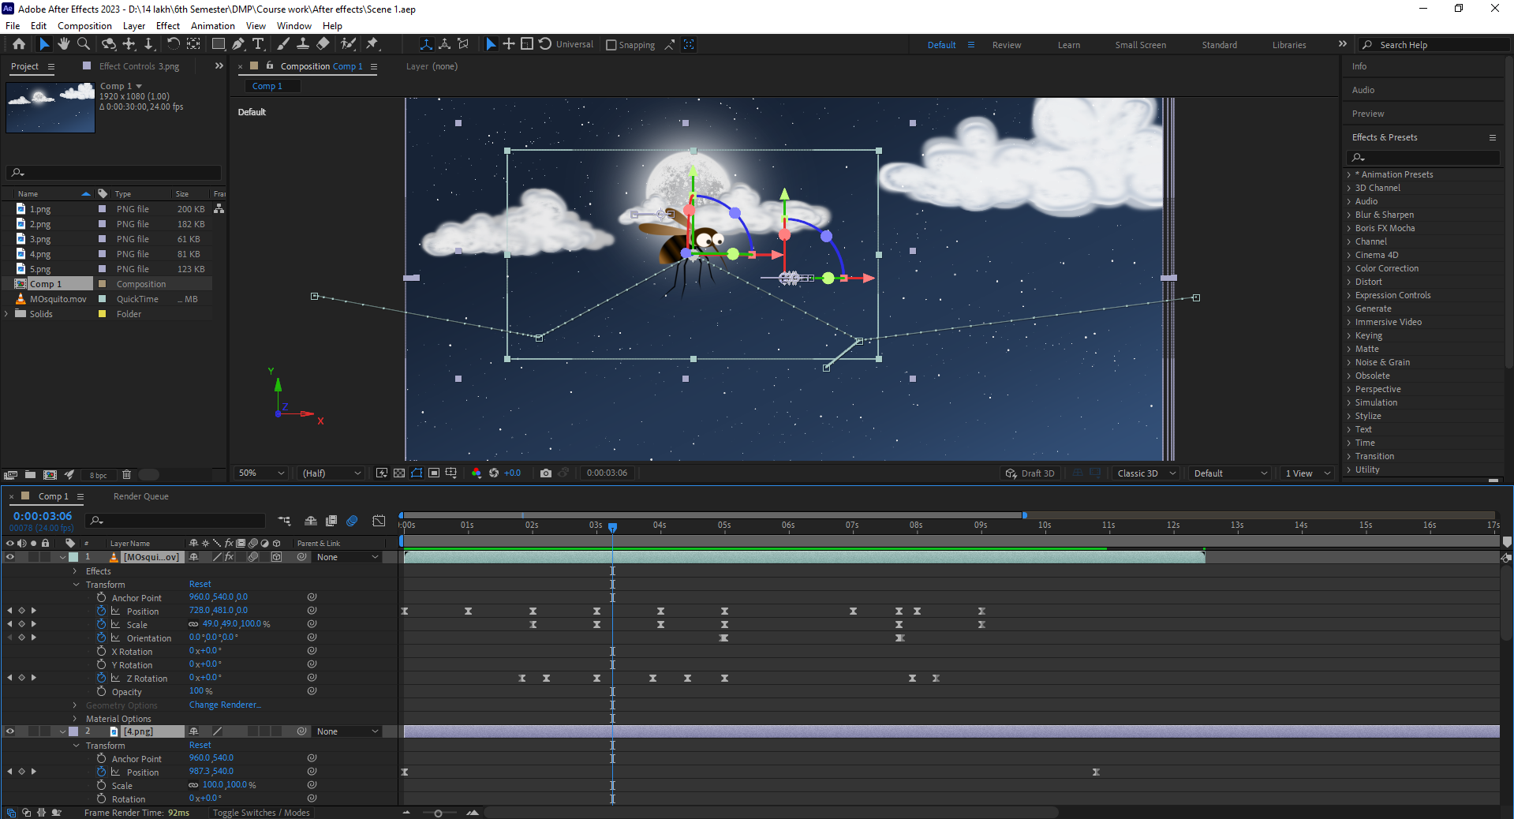

Figure 38

A day and night scene were already made in fire alpaca where in night scene the mosquito is being animated entering the house through window. For its realistic animation some effects like wiggle position and motion blur effects were used.

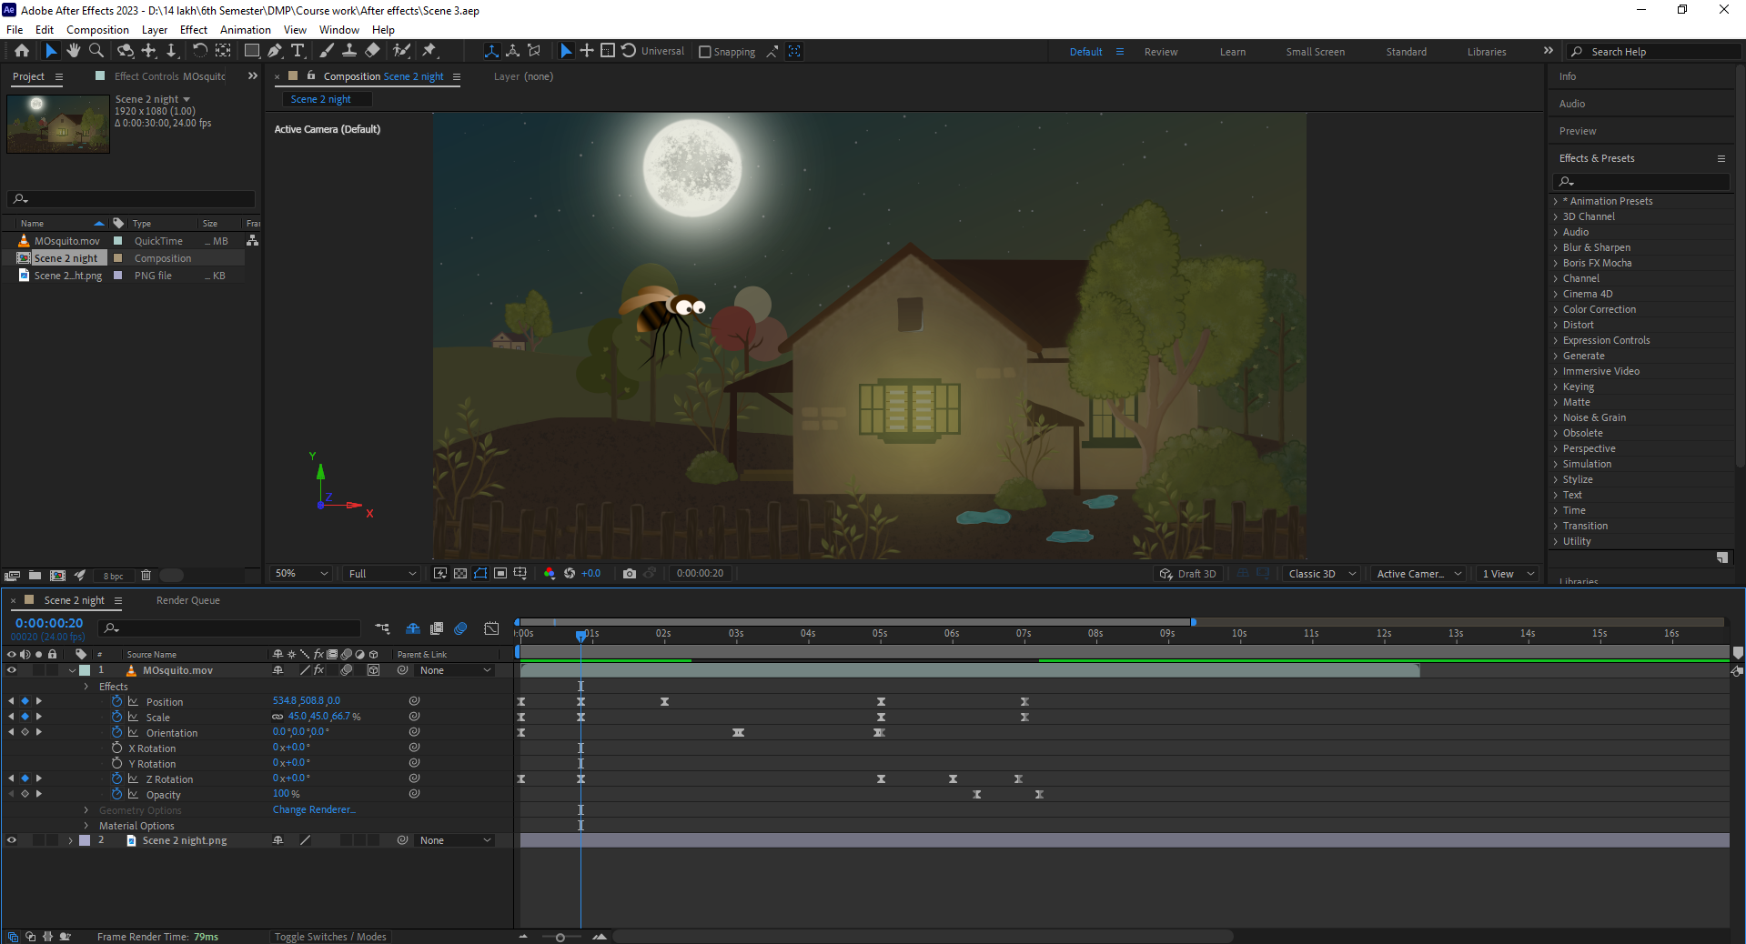

Figure 39

At this scene the nose bubbles was made in after effect using pen tool filling it with related colours and animated its scale to increase and decrease its size. After that the mouth breathing was animated using two layes of mouth. Then the mosquito’s position and scale is animated where it bites the character. Then after the preacursion like mosqito net, mosquito coils, etc are being show by adding a null object and parenting it then animation its scale.

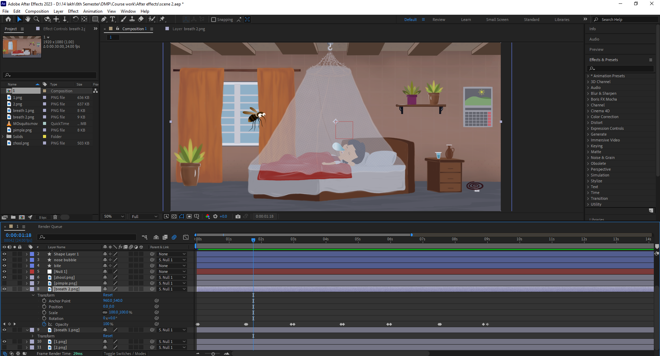

Figure 40

Animating the last scene, it was a challenging part because the background, house and character should be animated in 3d form where a camera first and the camera moves towards the hospital. Although all the keyframes were set and the background blur effects were used to make the animation more realism.

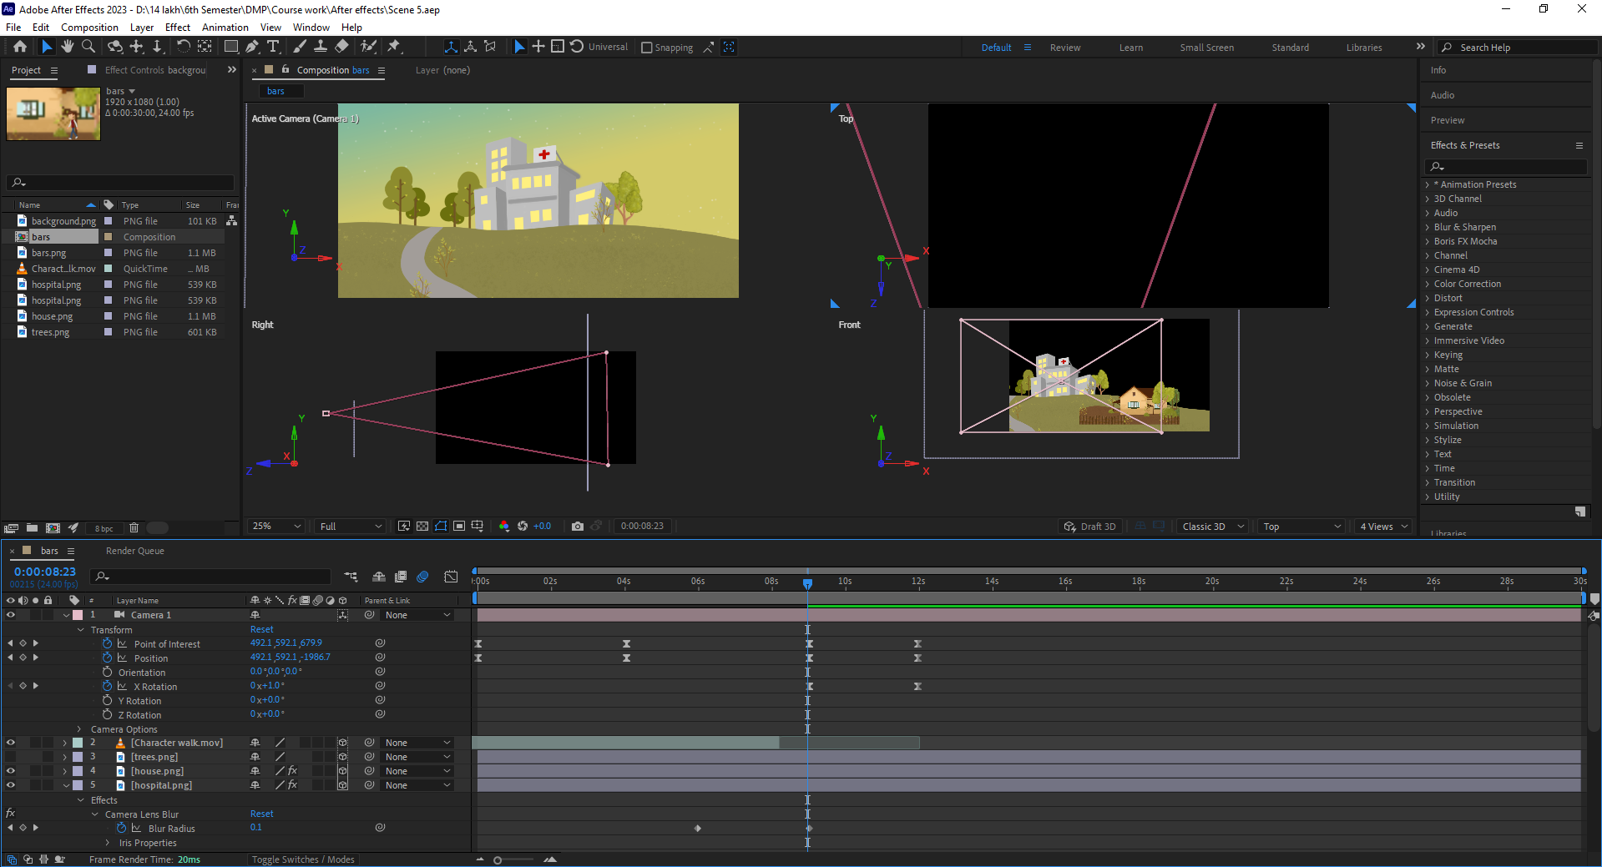

Figure 41

### VFX

For the smoke effect coming from mosquito coil. It was made by using particle playground effects where its particle size, gravity and colour setting were adjusted. Lastly its direction was being programmed by setting a code for realism effect.

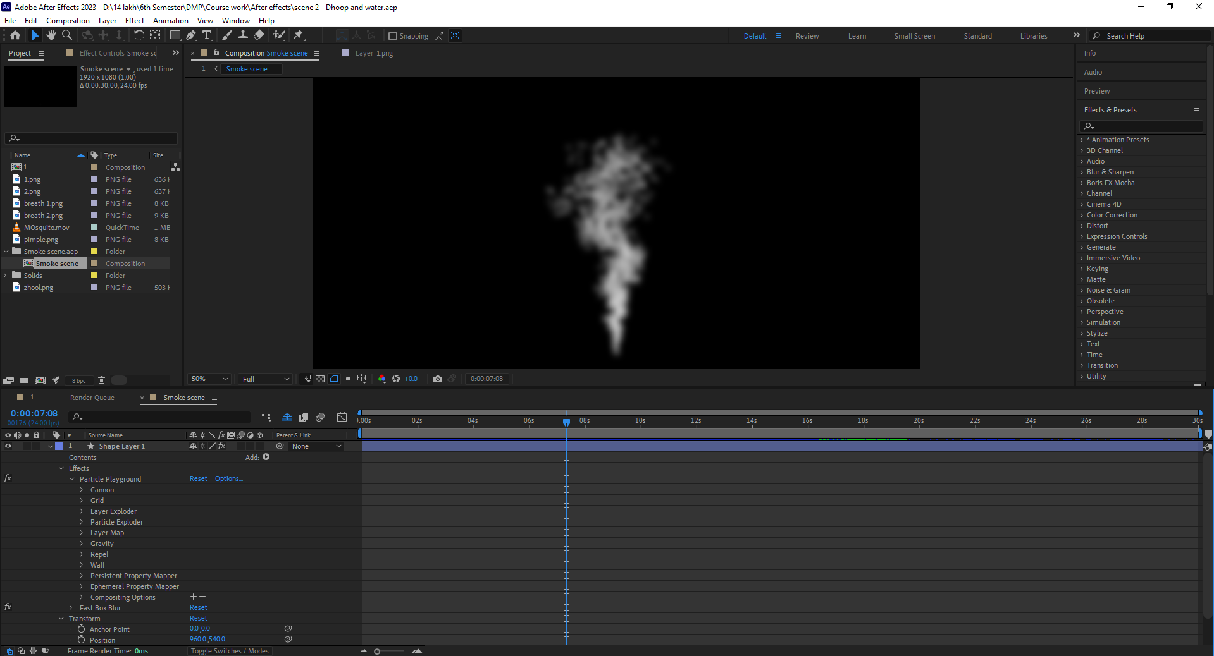

Figure 42

Also, it was made in different file where the scene couldn’t handle the effect then the effect was imported to the scene and scaled its size to fit into the scene.

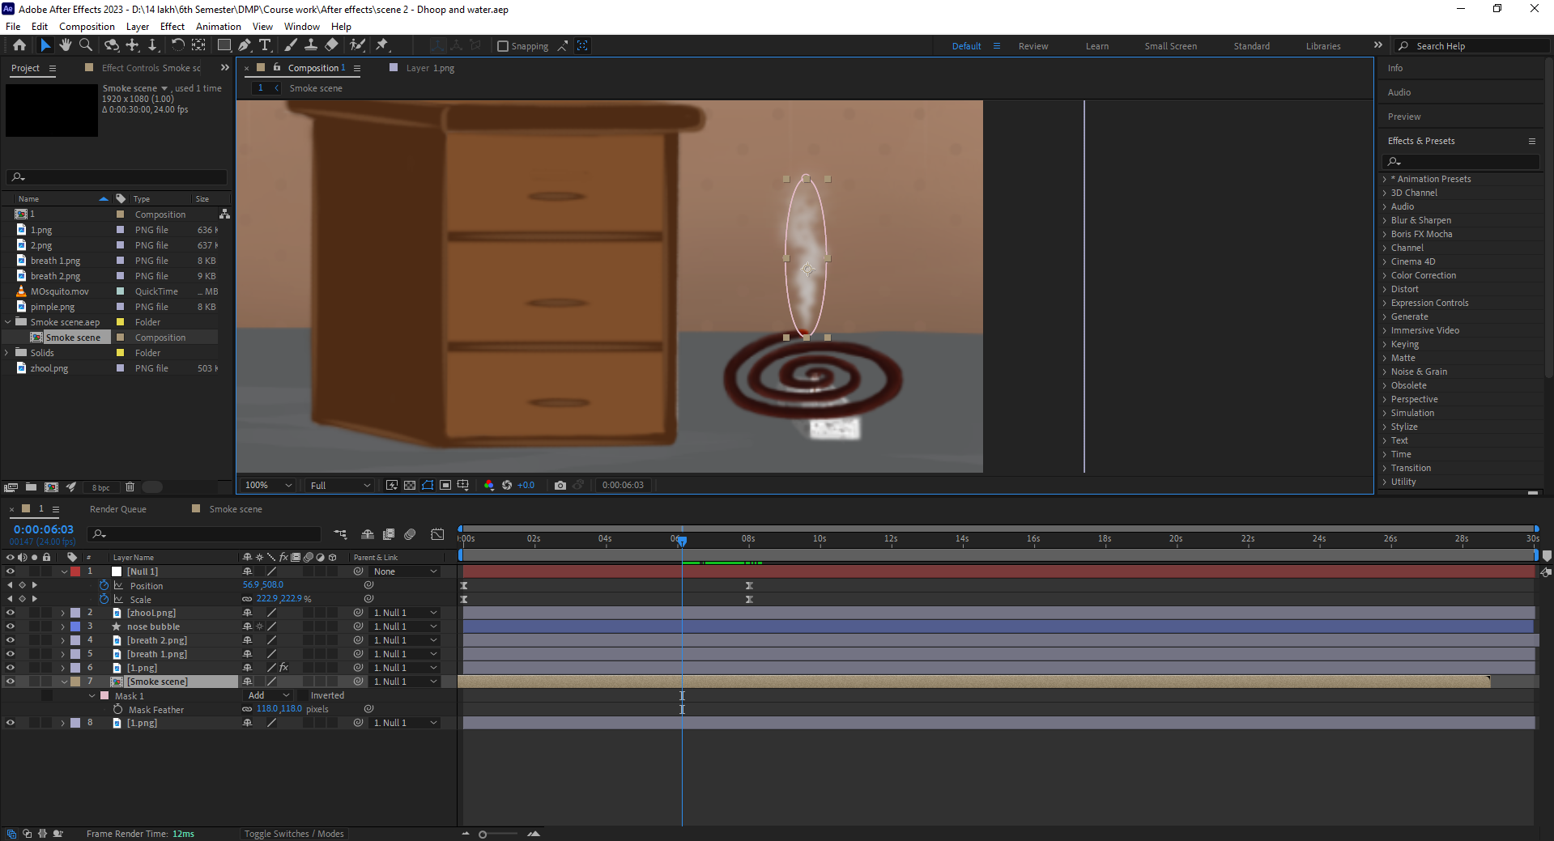

Figure 43

### Rendering

After completing all the process before render, the scenes were added to render queue, and its setting were adjusted and rendered in 1920x1080p 24fps h.264 format. The animation was exported without any problems.

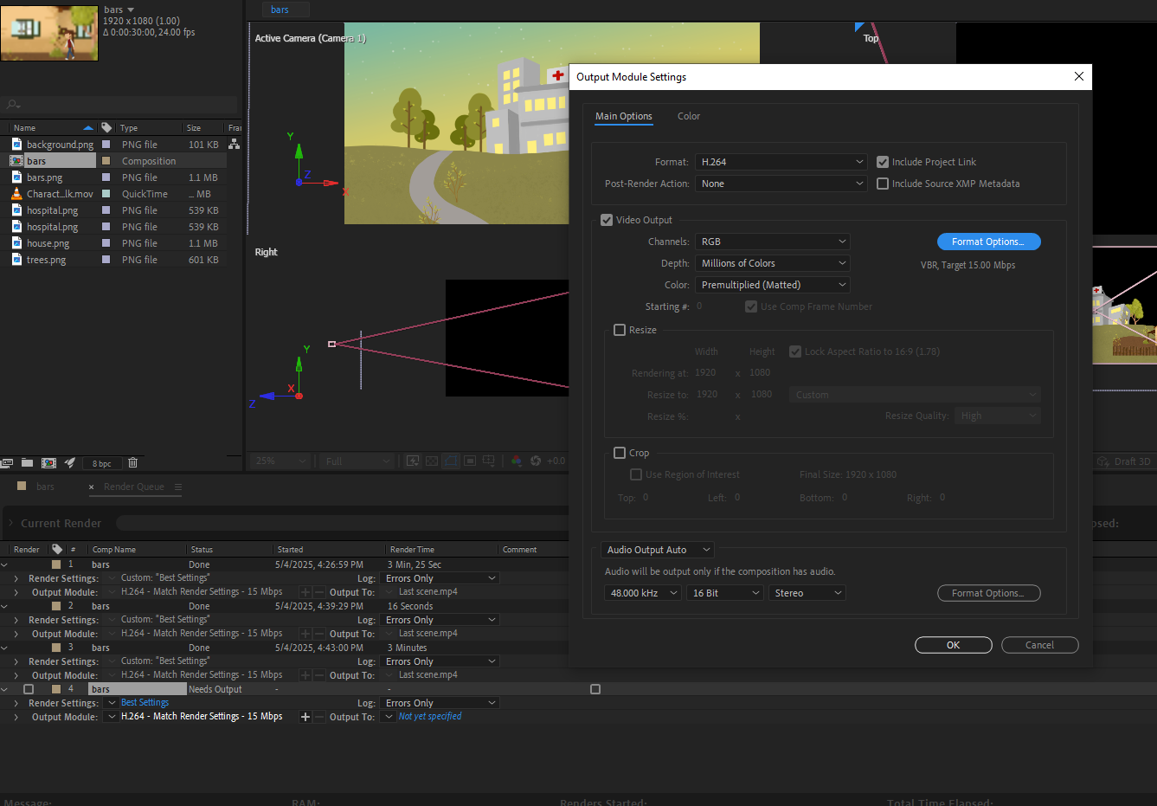

Figure 44

For some scene only the mosquito was rendered in Alpha+RGB layer in a quick time format for animation. It was rendered successfully.

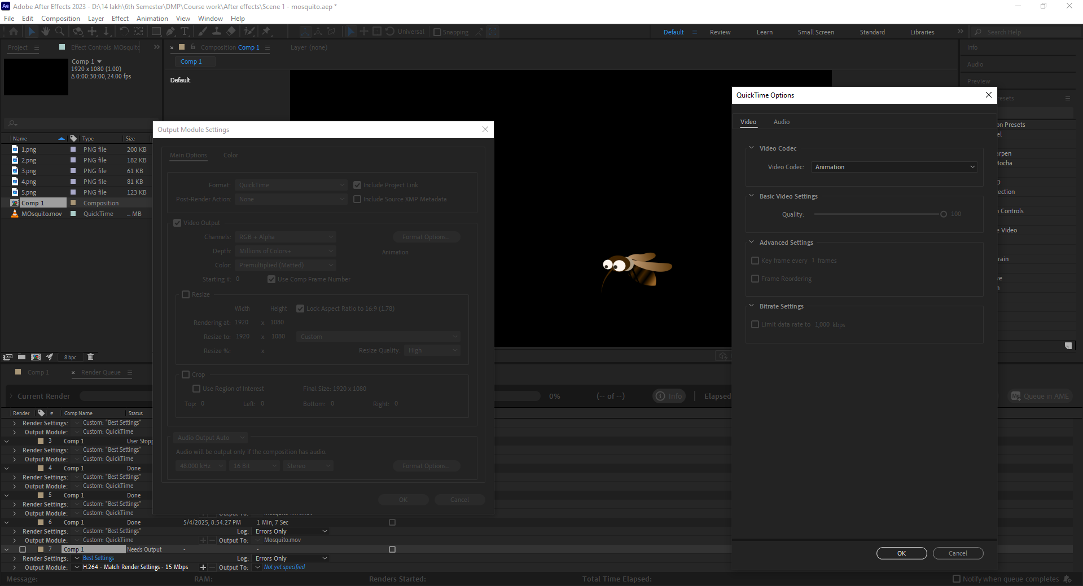

Figure 45

## Post-production

### Editing and Compiling

After rendering the image and animation from aftereffects then the videos were compiled and edited in Premier pro.

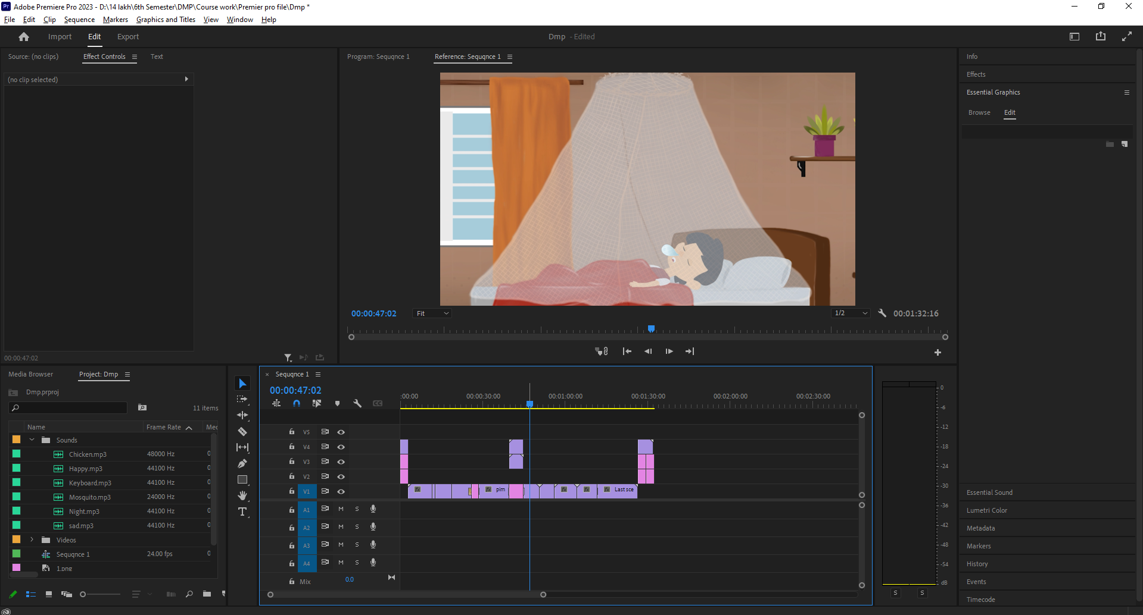

Figure 46

Some adjustment layers are added for text animation and to create an alpha animation.

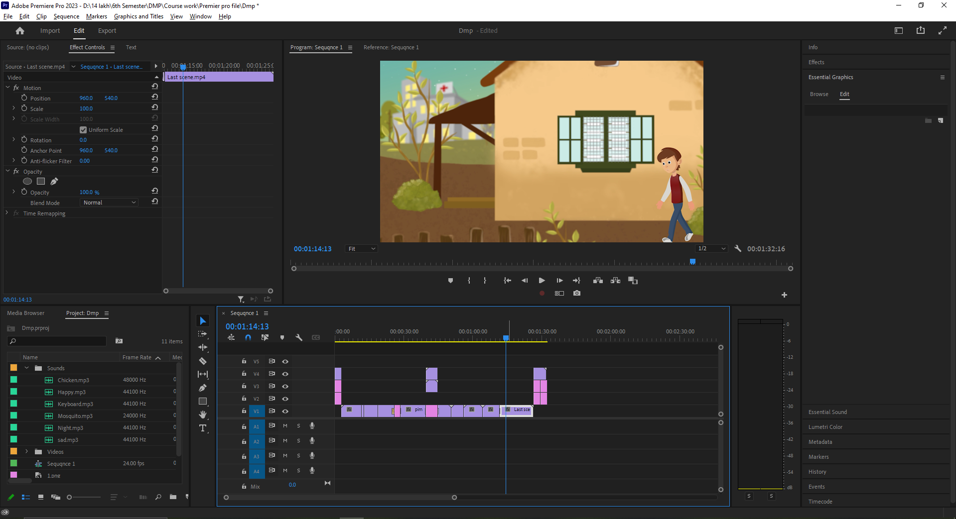

Figure 47

### Adding sound

After editing and compiling the videos the sounds effects were added like of morning rooster sound, keyboard clicking, mosquito buzzing, etc

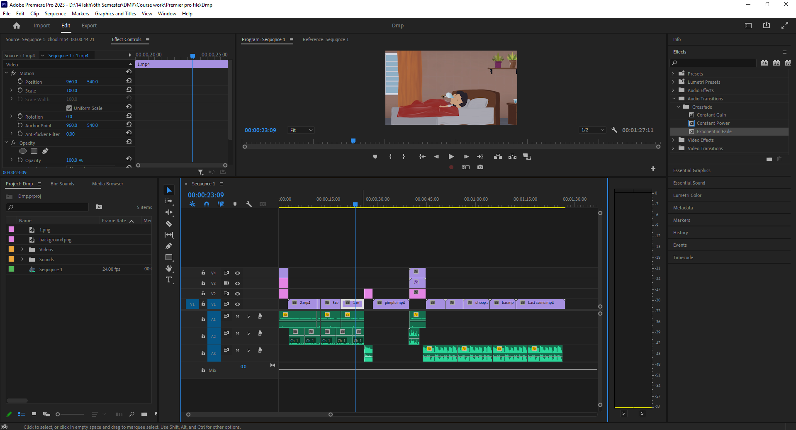

Figure 48 sound

After some sound effects the sad and happy music were added to the video because the flow of the video goes from sad to happy with uplifting the music to encourage the viewers according to the script.

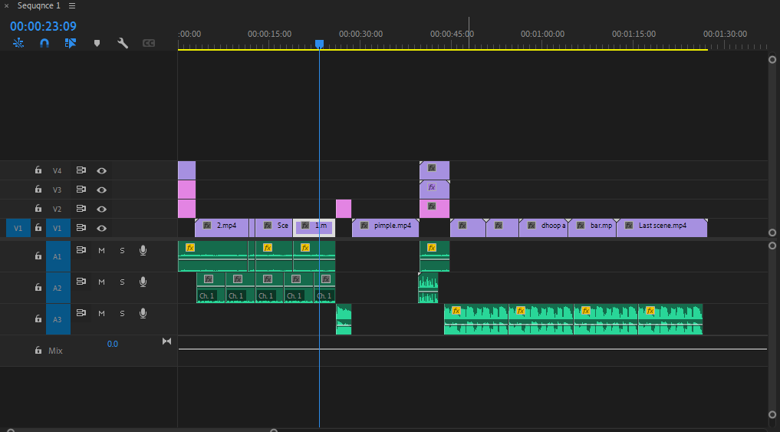

Figure 49 sound 1

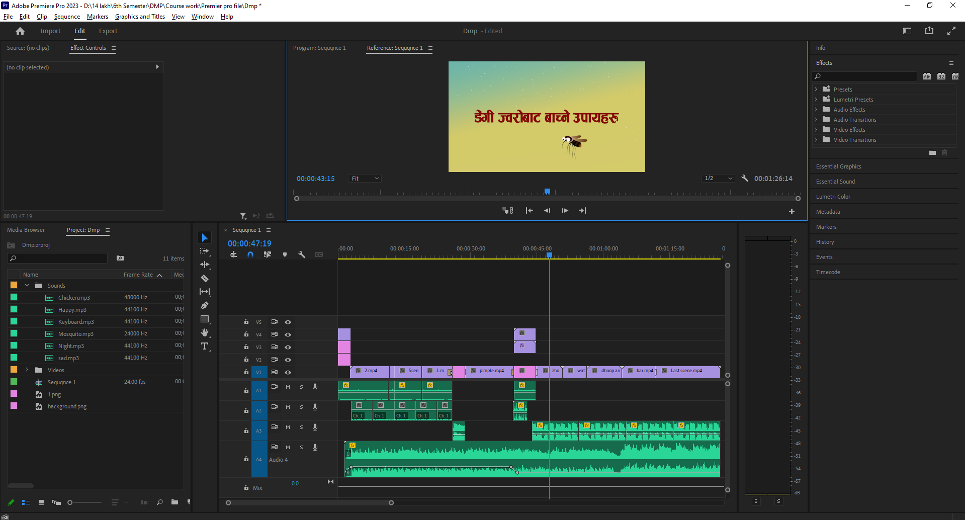

Figure 50

Lastly the voice over were added to the video where it specifies the key points explaining its causes and prevention.

### Rendering

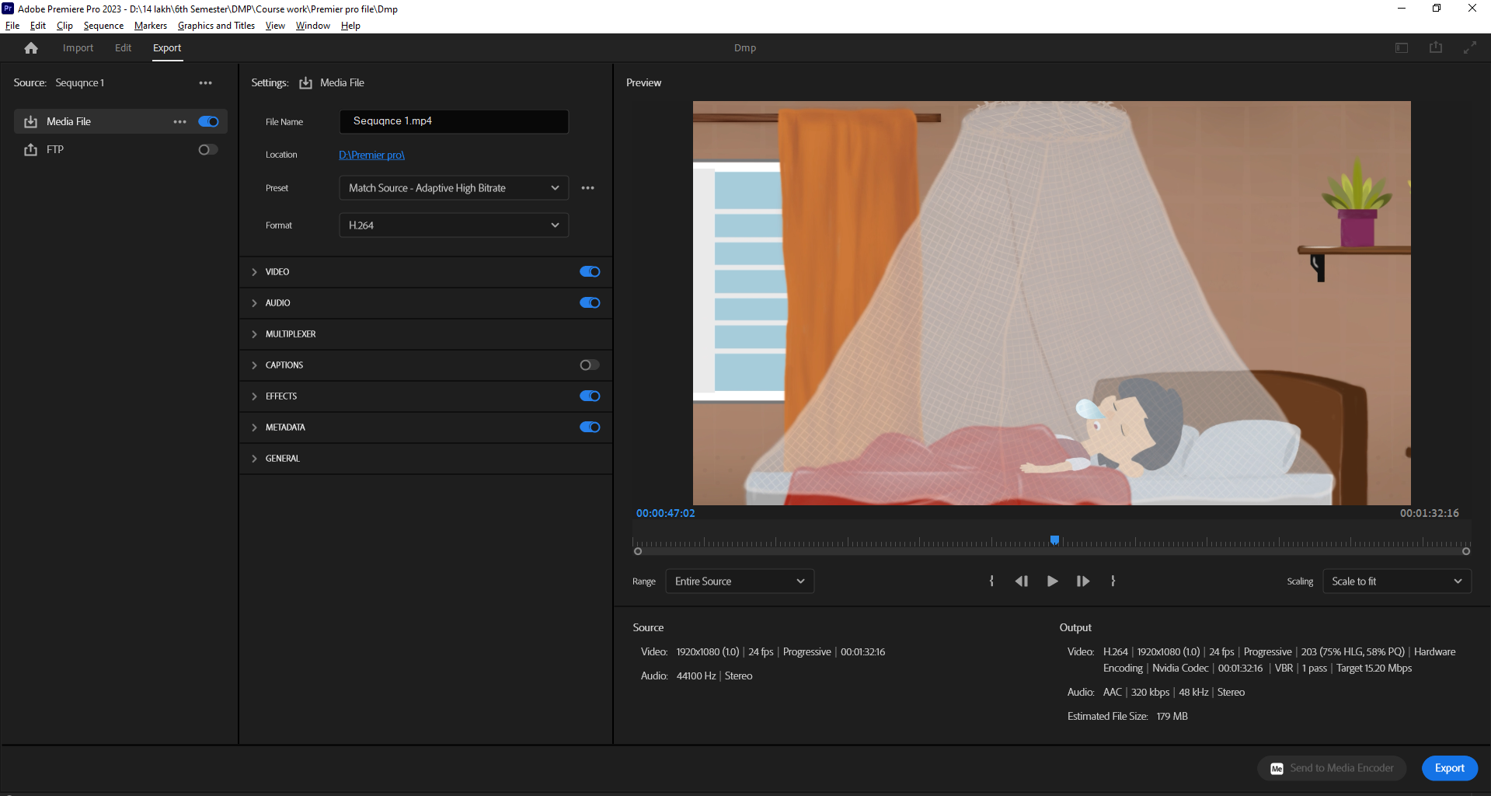

Figure 51 rendering

It is the final process of post-production where the video is being rendered in 1920x1080p at 24fps in h.264 format.

# Resources

## Software used

* **Fire Alpaca –** used for arts and designing backgrounds.
* **Adobe Illustrator –** used for designing the characters.
* **Adobe After Effects –** used for animation and effects.
* **Adobe Premier Pro –** used for composition and editing videos.
* **Toon boom –** used for rigging and walk cycle of the character.
* **Excel –** used for Gantt charts for scheduling.

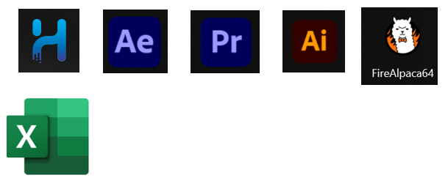

Figure 52 Software

## Hardware used

### Laptop

Processor: 11th Gen Intel(R) Core (TM) i7-11800H @ 2.30GHz 2.30 GHz

Graphics card: NVIDIA GeForce RTX 3070 Laptop GPU

RAM: 16GB

### Graphic tablet

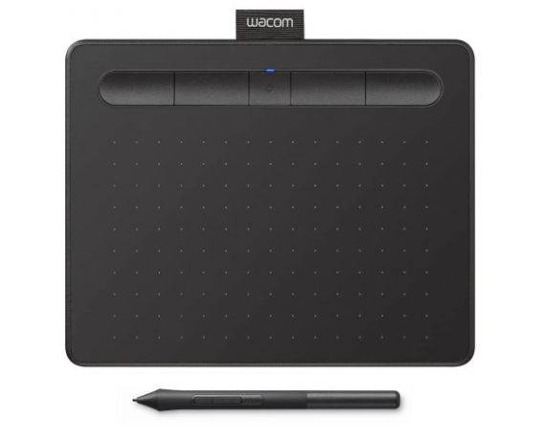

Figure 53 (Gadgets house nepal, n.d.)

Used for designing backgrounds, characters and colouring it.

## Website used

* **YouTube -** used for research and reference videos for the project.
* **Pixabay -** used for adding sound effects of different objects.
* **Pinterest -** used for referencing character and mosquito designing.



Figure 54 Websites

# Problem faced

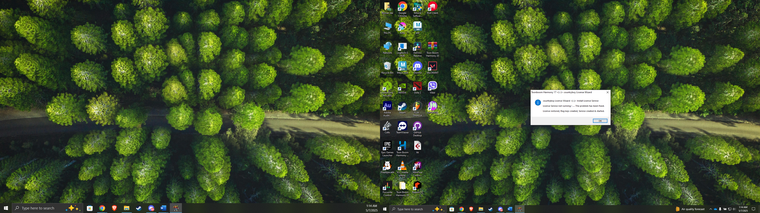

Figure 55 toonboom problem

During the rigging process, I was faced with a technical issue that rendered my laptop inoperable to run Toon Boom Harmony due to either performance or compatibility issues. Despite seeking help from the IT Department, the problem could not be solved. I thus sought help from Bijay Shakya Sir. His guidance and support helped me to complete the rigging process. His assistance during this critical time resolved my technical problem.

# User Testing & Findings

## Survey results

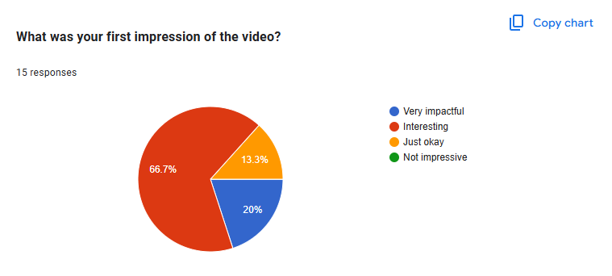

Figure 56

Almost half (46.7%) of the 15 respondents are ready to watch such videos, and a slightly higher percentage (53.3%) are unsure ("Maybe"). No one said "No".

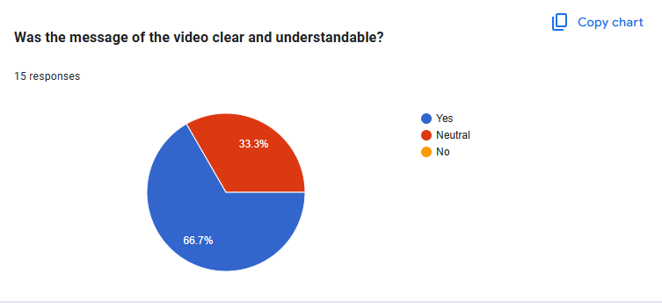

Figure 57

Of 15 responses, the vast majority (66.7%) said that the message in the video was understandable and clear, with a third (33.3%) being neutral. No one reported that they said the message was unclear. This suggests the video was very effective at getting its message across to this sample.

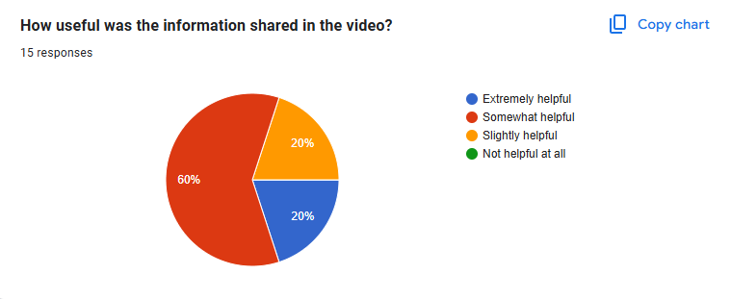

Figure 58

Of 15 individuals, how useful the information in the video was varied. It was "Somewhat helpful" to most (60%), and 20% reported it as "Extremely helpful." Another 20% reported that the information was "Slightly helpful," and no one reported that it was "Not helpful at all." That is, most viewers did have some use for the information, but there was no consensus that it was extremely helpful.

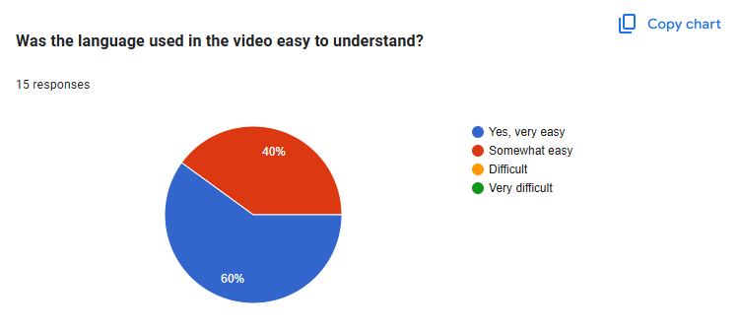

Figure 59

Out of 15 subjects, a significant majority (60%) found the language in the video "Yes, very easy" to be easily understandable. Quite a significant section (40%) found the language "Somewhat easy." Nobody found the language "Difficult" or "Very difficult," which implies the language used fell generally within reach of the listening audience.

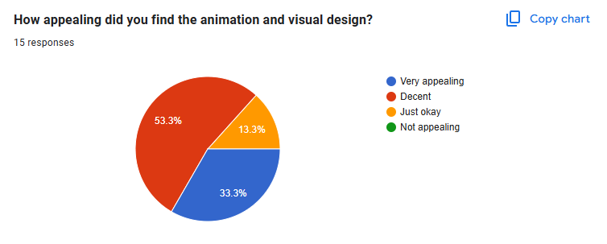

Figure 60

Of 15 responses, the opinions about the animation and visual design were equally divided. Slightly more than half (53.3%) responded that it was "Decent," while a third (33.3%) responded that it was "Very appealing." Fewer (13.3%) responded that it was "Just okay," while no one responded that it was "Not appealing." This means that while the majority of viewers didn't particularly care for the visuals, they were really quite acceptable in general, with a good percentage viewing them as very appealing.

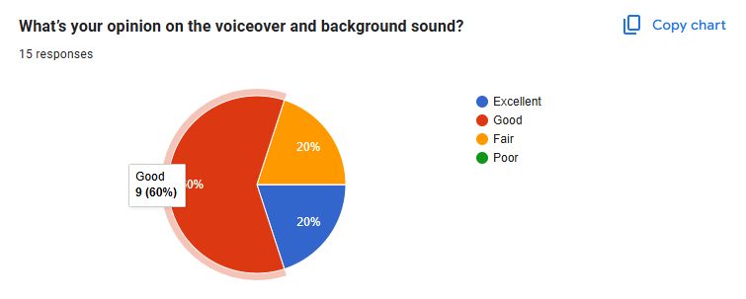

Figure 61

Of 15 answers, opinions about the animation and visual design were divided. More than half (53.3%) believed it was "Decent," and one-third (33.3%) believed it was "Very appealing." Fewer (13.3%) believed it was "Just okay," and no one believed it was "Not appealing." This shows that while most viewers did not believe the visuals to be exceptionally great, they were generally fine, with a large number believing them very appealing.

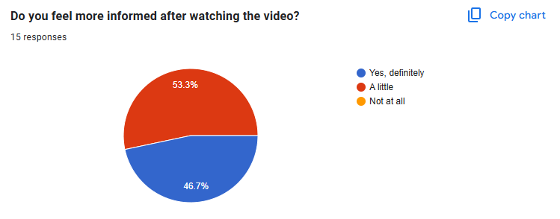

Figure 62

Of 15 interviewees, a small minority of nearly half (46.7%) "definitely" said they were more informed after watching the video. A marginally larger number (53.3%) said they were "a little" more informed. No interviewees said they were "not at all" more informed. This suggests that although the video did indicate some level of gain for information for all respondents, the impact was stronger for nearly half of them.

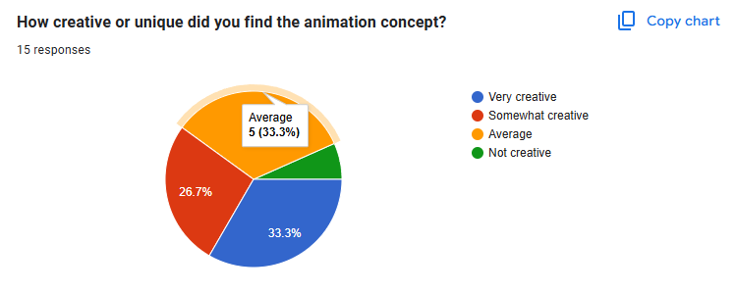

Figure 63

Out of the 15 participants, there was mixed feedback on the creativity of the animation idea. A third (33.3%) believed it was "very creative," while a slightly lesser proportion (26.7%) regarded it as "somewhat creative." Another third (33.3%) found it "average," and a small fraction (6.7%, as inferred by the leftover portion) found it "not creative." This suggests mixed acceptance of the creativity of the animation idea, with "very creative" and "average" being the most common feedback.

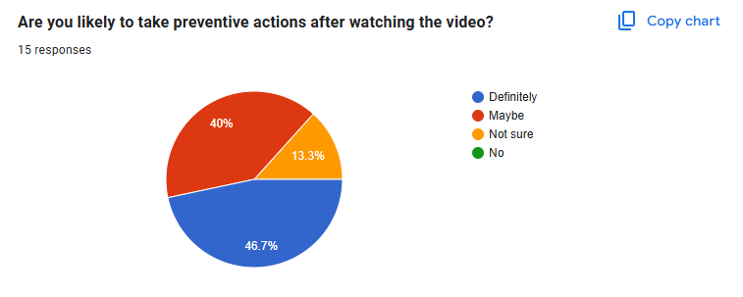

Figure 64

Among 15 responses, nearly half (46.7%) responded with "Definitely" to having preventive action taken after watching the video. Almost half (40%) responded "Maybe," while a smaller response was "Not sure" (13.3%). No one responded that they would "Not act preventively. This suggests the video had an effect in getting preventive behaviour favourable to most audience members.

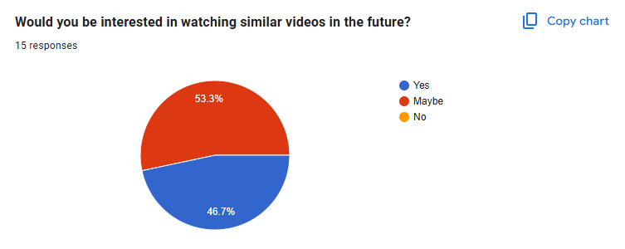

Figure 65

In terms of future interest in videos similar to this one, out of the 15 respondents, over half (53.3%) answered "Maybe," while nearly half (46.7%) answered "Yes." No one answered "No" interest. This shows an eager willingness to similar material, albeit with a slightly higher percentage uncertain but not opposed.

# Third party evaluation

A third-party evaluation was conducted to generate objective remarks about both the effectiveness and clarity aspects of the animated dengue awareness film. The selected group of observers who did not participate in production viewed the completed product for response evaluation. Visual attractiveness together with message clarity and appropriate timing and audio quality received attention from evaluators who assessed the animated dengue awareness movie's overall effect. The third-party review both found minor areas that needed improvement and confirmed the video delivered its intended message clearly to diverse viewers.

## Anush Shakya

Your animation work totally blows me away. Your composition images bring beauty and depth to the story as well as visually. Frame is excellent in using voice-over audio and engaging the audience. You certainly took extreme care of every animation, and the result as an animated video speaks for itself. Keep up your great work.

## Ranjan Adhikari

Your animated work excels remarkably. The background artwork establishes dimensional effects that enhance situational mood and concurrently the character visuals expand narrative visual appeal. A meticulous approach guided the making of every visual element in both background and character design until their cumulative achievement became the completed animation. Keep up the great job!

## Kriza Limbu

Your animation work is outstanding. Combining well-structured plots with images designed to transmit defined themes results in enhanced overall impact. Careful scene building matches the story needs so the message remains both compelling and easily understandable. Multiple rounds of careful development between storyline and visual storytelling have produced a compelling meaningful animated video. Keep up the amazing job!

# Conclusion

In this coursework, the students must work on a specific topic and show their knowledge and skill learned thought the year. So, for my DMP project, I decided to make and awareness animation video. In this documentation the process of research, finding client, pre-production, production and post-production. It also includes the testing and survey of the users with a conclusion.

It was a great experience working with the client and making an animated video. After doing the research and use of creativity the awareness animated video was made presenting the causes and prevention of the disease. The project highlighted the importance of good communication, teamwork, and flexibility in the achievement of its objectives.

Hence, this project was successfully completed in making and animated awareness video to aware the people about the disease ‘Dengue’. The documentation included all works like research, production phases, software used, client finalization, tools and designs for creating the final product. The animated video also conveys the messages about the symptoms and remedies to prevent it in educational and entertainment ways which helped in educating the targeted audiences successfully.

Lastly, I would like to thank my internal and external supervisors Mr. Bijay Shakya sir and Ms. Aarsha Maharjan maam for providing the proper guidance and helping throughout my project.

# References

alexander, H., 2023. *envato.* [Online]   
Available at: https://elements.envato.com/learn/after-effects-tutorials-beginners?adposition=&gad_source=1&gad_campaignid=19579623273&gbraid=0AAAAADclSXnIkGGN-IlKwx18_1JNCg92U&gclid=Cj0KCQjww-HABhCGARIsALLO6XxneJo7hnG8TfAVfQ8Uk3gGeMXD0KN5bl3rF5TZ6rYAL69GgInmsDEaAss-EAL  
[Accessed 6 May 2025].

alternative view studios, n.d. *alternative view studios.* [Online]   
Available at: https://avstudios.com/post/benefits-of-using-animation-in-education/  
[Accessed 6 May 2025].

austin visuals, n.d. *medical 3d animation company.* [Online]   
Available at: https://medical3danimationcompany.com/medical-animation-explainer-video/  
[Accessed 6 May 2025].

Barker, S., n.d. *VMG studio.* [Online]   
Available at: https://blog.vmgstudios.com/motion-graphics-versus-animation  
[Accessed 6 May 2025].

call center helper, n.d. *call center helper.* [Online]   
Available at: https://www.callcentrehelper.com/understanding-your-customers-techniques-154086.htm  
[Accessed 6 May 2025].

Gadgets house nepal, n.d. *Gadgets house nepal.* [Online]   
Available at: https://gadgethousenepal.com/product/wacom-intuos-bluetooth-graphics-drawing-tablet/  
[Accessed 6 May 2025].

Harmony 20 Essentials, n.d. *Harmony 20 Essentials.* [Online]   
Available at: https://docs.toonboom.com/help/harmony-20/essentials/about/about.html#:~:text=Toon%20Boom%20Harmony%20Essentials%20is,games%20and%20many%20other%20productions.  
[Accessed 6 May 2025].

helyer, R., 2023. *Make use of.* [Online]   
Available at: https://www.makeuseof.com/what-is-firealpaca-paint-software/#:~:text=FireAlpaca%20is%20a%20digital%20art,tutorials%20for%20using%20its%20software.  
[Accessed 6 May 2025].

Mitchell, D., 2021. *udemy.* [Online]   
Available at: https://blog.udemy.com/what-is-adobe-illustrator-used-for/?utm_source=adwords&utm_medium=udemyads&utm_campaign=Search_DSA_GammaCatchall_NonP_la.EN_cc.ROW-English&campaigntype=Search&portfolio=ROW-English&language=EN&product=Course&test=&audience=DSA&topic  
[Accessed 6 May 2025].

Muntasir, 2017. *iedunote.* [Online]   
Available at: https://www.iedunote.com/health-research/  
[Accessed 6 May 2025].

Patel, N., n.d. *Np digital.* [Online]   
Available at: https://neilpatel.com/blog/target-audience/  
[Accessed 6 May 2025].

Pixabay, n.d. *Pixabay.* [Online]   
Available at: https://pixabay.com/   
[Accessed 6 May 2025].

Smith, C., 2024. *American graphics institute.* [Online]   
Available at: https://www.agitraining.com/adobe/premiere-pro/classes/what-is-premiere-pro?srsltid=AfmBOor2TZiZCuo8cgvfo_HTP9CWHlVxMuTBZWkyPBWQg5X76mIVjgsm  
[Accessed 6 May 2025].

Toonz media group, n.d. *Toonz media group.* [Online]   
Available at: https://toonz.co/2023/06/26/behind-the-scenes-a-sneak-peek-into-the-animation-production-pipeline/  
[Accessed 6 May 2025].

# Bibliography

alexander, H., 2023. *envato.* [Online]   
Available at: https://elements.envato.com/learn/after-effects-tutorials-beginners?adposition=&gad_source=1&gad_campaignid=19579623273&gbraid=0AAAAADclSXnIkGGN-IlKwx18_1JNCg92U&gclid=Cj0KCQjww-HABhCGARIsALLO6XxneJo7hnG8TfAVfQ8Uk3gGeMXD0KN5bl3rF5TZ6rYAL69GgInmsDEaAss-EAL  
[Accessed 6 May 2025].

alternative view studios, n.d. *alternative view studios.* [Online]   
Available at: https://avstudios.com/post/benefits-of-using-animation-in-education/  
[Accessed 6 May 2025].

austin visuals, n.d. *medical 3d animation company.* [Online]   
Available at: https://medical3danimationcompany.com/medical-animation-explainer-video/  
[Accessed 6 May 2025].

Barker, S., n.d. *VMG studio.* [Online]   
Available at: https://blog.vmgstudios.com/motion-graphics-versus-animation  
[Accessed 6 May 2025].

call center helper, n.d. *call center helper.* [Online]   
Available at: https://www.callcentrehelper.com/understanding-your-customers-techniques-154086.htm  
[Accessed 6 May 2025].

Gadgets house nepal, n.d. *Gadgets house nepal.* [Online]   
Available at: https://gadgethousenepal.com/product/wacom-intuos-bluetooth-graphics-drawing-tablet/  
[Accessed 6 May 2025].

Harmony 20 Essentials, n.d. *Harmony 20 Essentials.* [Online]   
Available at: https://docs.toonboom.com/help/harmony-20/essentials/about/about.html#:~:text=Toon%20Boom%20Harmony%20Essentials%20is,games%20and%20many%20other%20productions.  
[Accessed 6 May 2025].

helyer, R., 2023. *Make use of.* [Online]   
Available at: https://www.makeuseof.com/what-is-firealpaca-paint-software/#:~:text=FireAlpaca%20is%20a%20digital%20art,tutorials%20for%20using%20its%20software.  
[Accessed 6 May 2025].

Mitchell, D., 2021. *udemy.* [Online]   
Available at: https://blog.udemy.com/what-is-adobe-illustrator-used-for/?utm_source=adwords&utm_medium=udemyads&utm_campaign=Search_DSA_GammaCatchall_NonP_la.EN_cc.ROW-English&campaigntype=Search&portfolio=ROW-English&language=EN&product=Course&test=&audience=DSA&topic  
[Accessed 6 May 2025].

Muntasir, 2017. *iedunote.* [Online]   
Available at: https://www.iedunote.com/health-research/  
[Accessed 6 May 2025].

Patel, N., n.d. *Np digital.* [Online]   
Available at: https://neilpatel.com/blog/target-audience/  
[Accessed 6 May 2025].

Pixabay, n.d. *Pixabay.* [Online]   
Available at: https://pixabay.com/   
[Accessed 6 May 2025].

Smith, C., 2024. *American graphics institute.* [Online]   
Available at: https://www.agitraining.com/adobe/premiere-pro/classes/what-is-premiere-pro?srsltid=AfmBOor2TZiZCuo8cgvfo_HTP9CWHlVxMuTBZWkyPBWQg5X76mIVjgsm  
[Accessed 6 May 2025].

Toonz media group, n.d. *Toonz media group.* [Online]   
Available at: https://toonz.co/2023/06/26/behind-the-scenes-a-sneak-peek-into-the-animation-production-pipeline/  
[Accessed 6 May 2025].

# Appendix

## Gantt Chart



Figure 66 Gantt chart 1



Figure 67 Gantt chart 2

## Approval letter

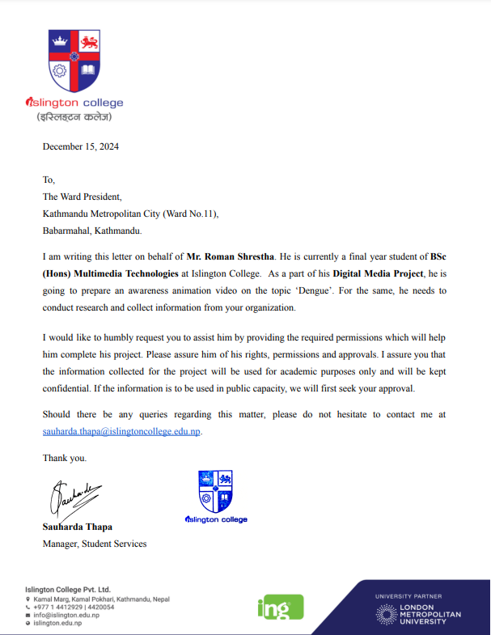

Figure 68 college letter

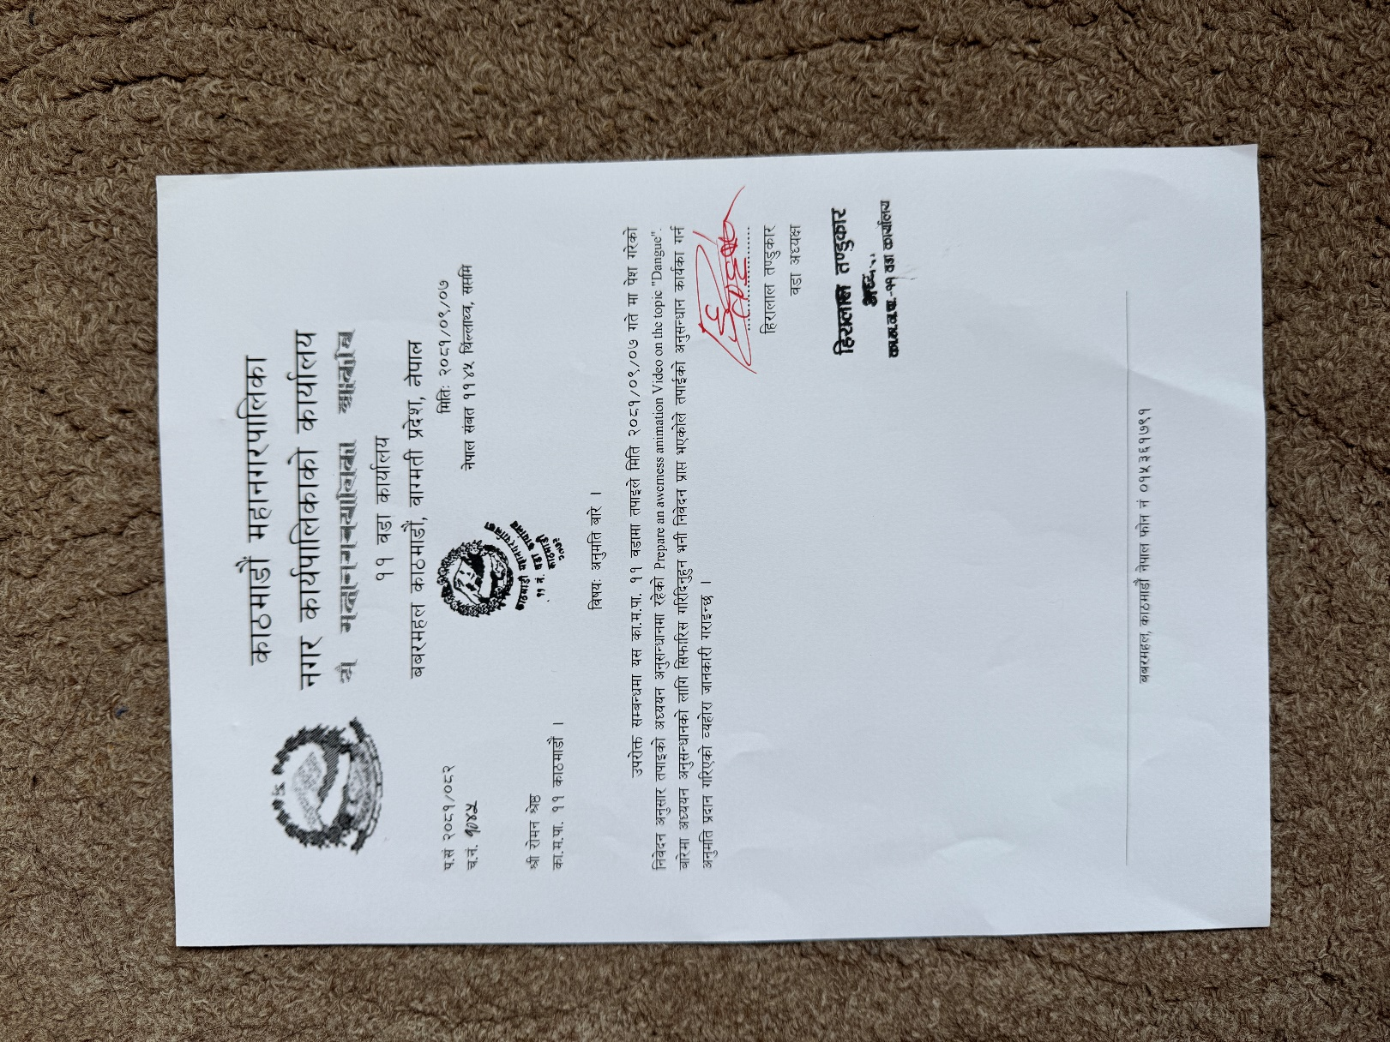

Figure 69 client letter

## Log sheet

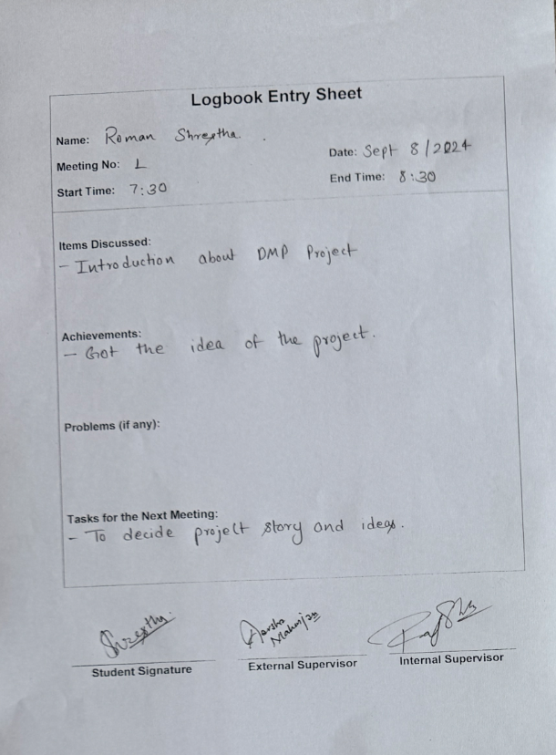

Figure 70 Log sheet 1

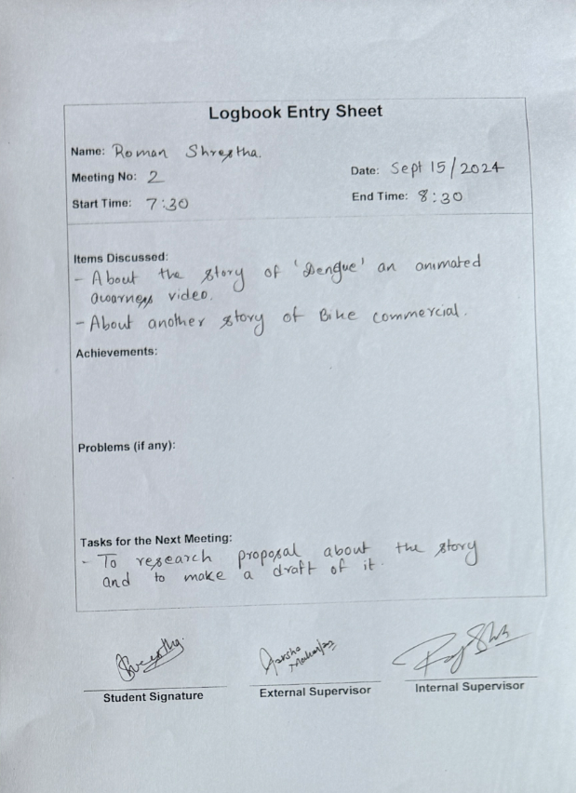

Figure 71 Log sheet 2

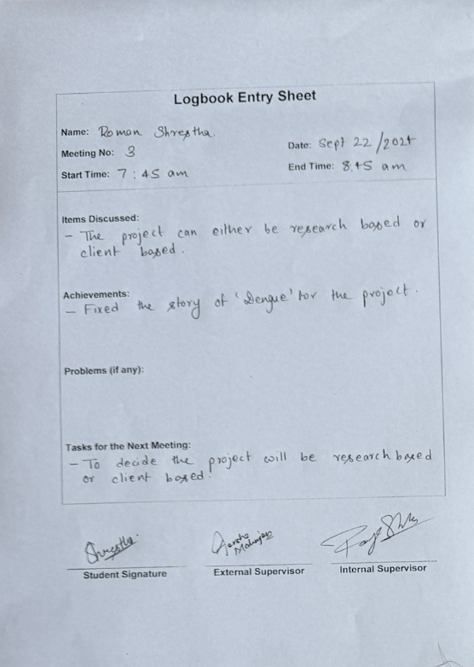

Figure 72 Log sheet 3

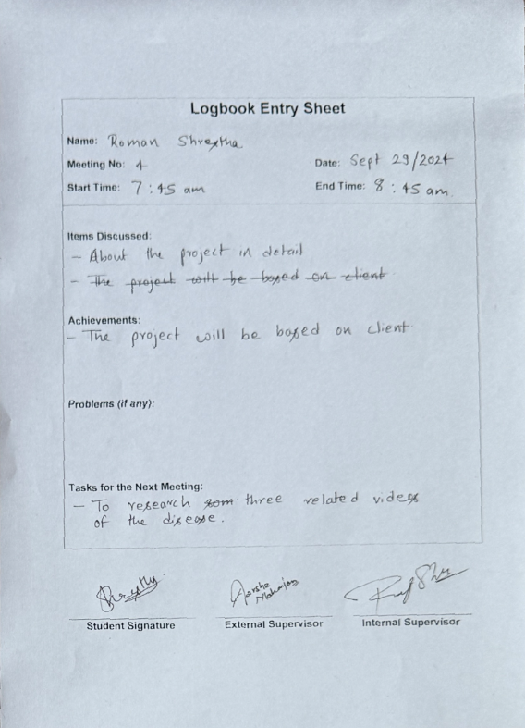

Figure 73 Log sheet 4

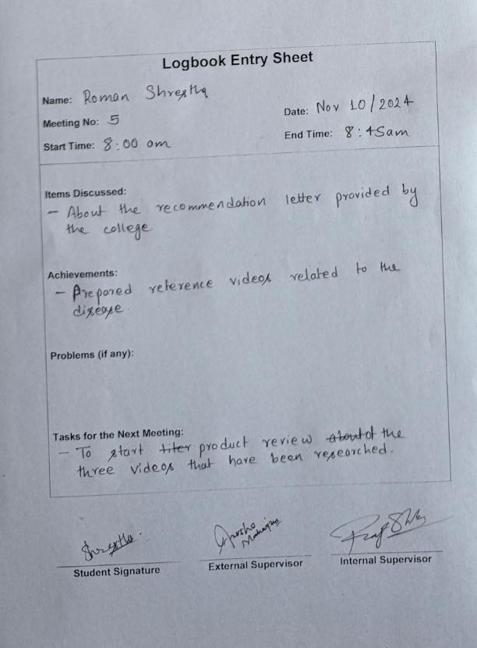

Figure 74 Log sheet 5

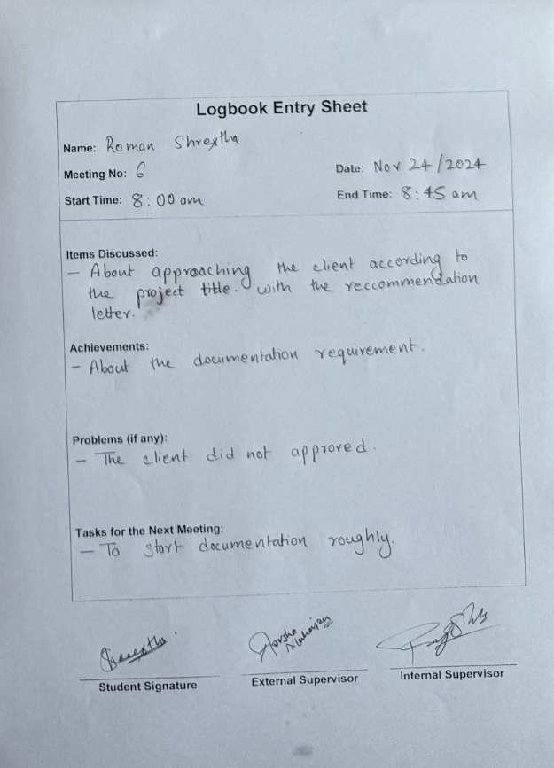

Figure 75 Log sheet 6

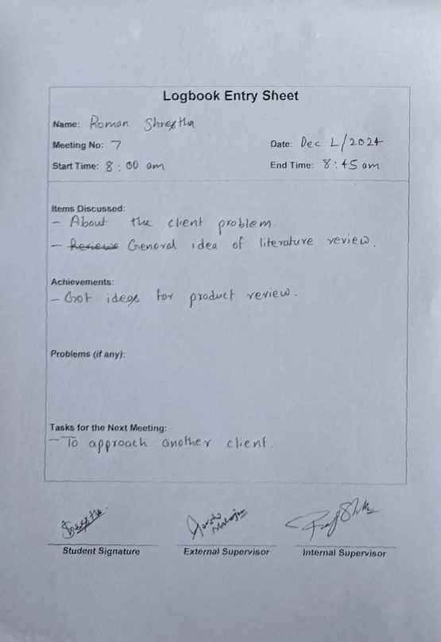

Figure 76 Log sheet 7

e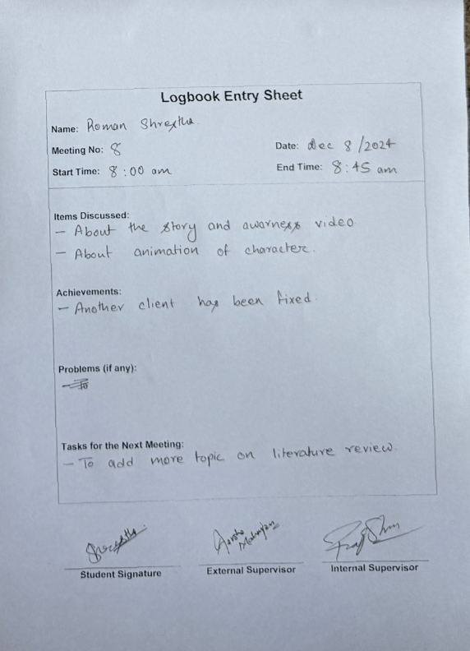

Figure 77 Log sheet 8

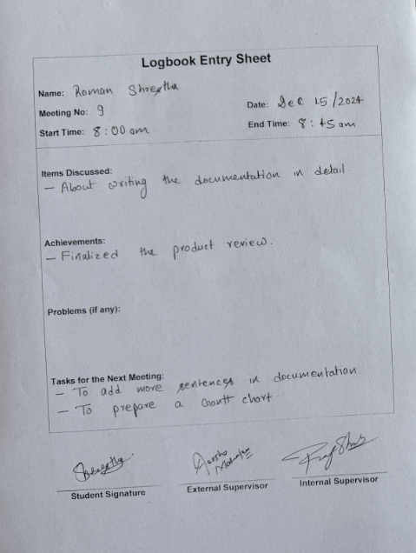

Figure 78 Log sheet 9

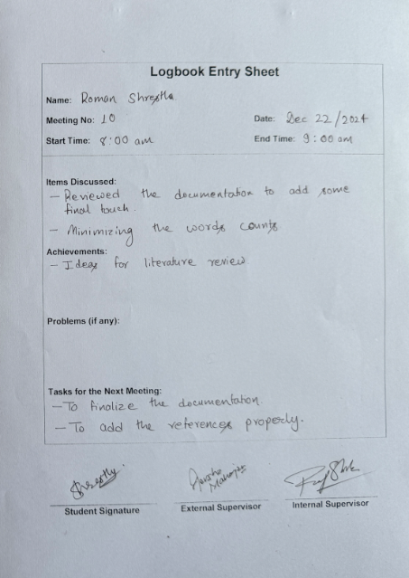

Figure 79 Log sheet 10

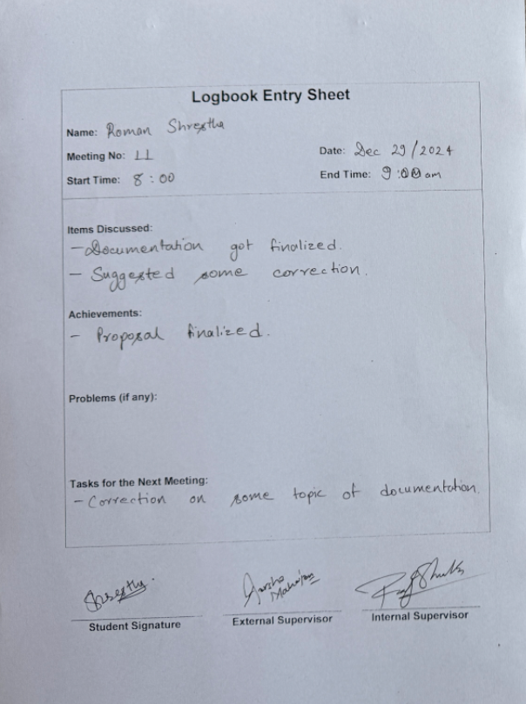

Figure 80 Log sheet 11

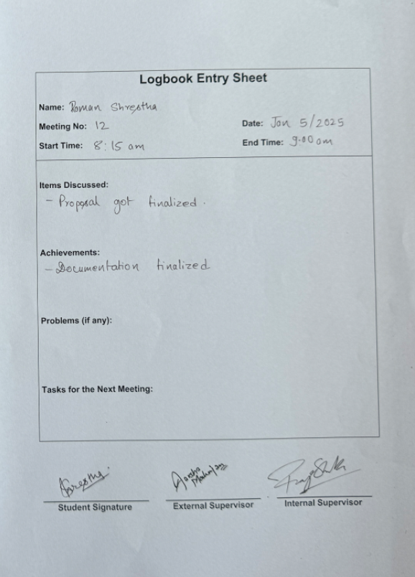

Figure 81 Log sheet 12

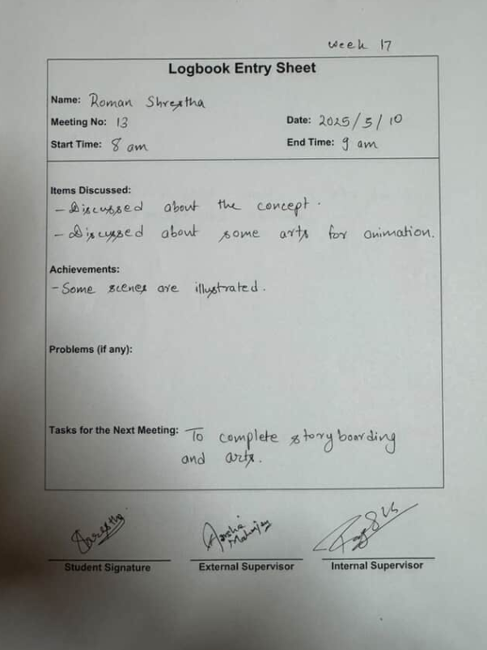

Figure 82 Log sheet 13

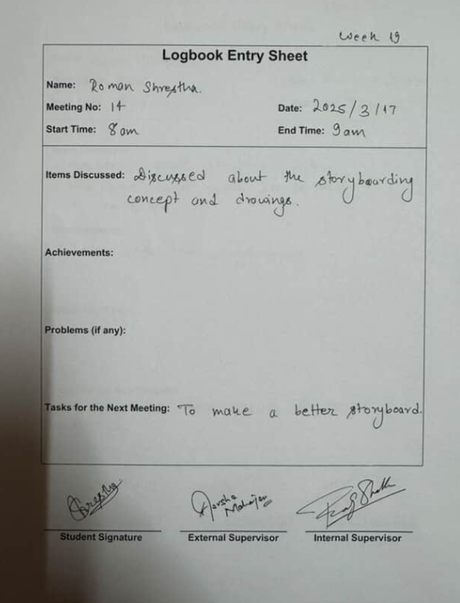

Figure 83 Log sheet 14

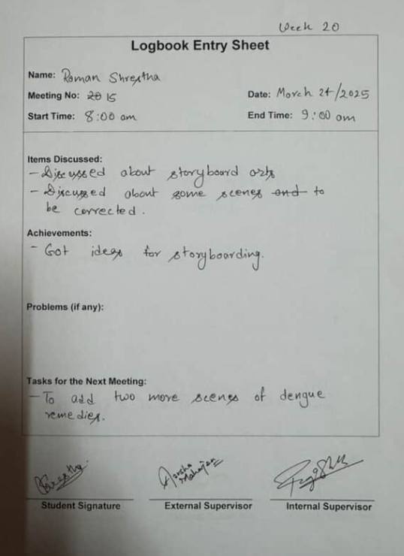

Figure 84 Log sheet 15

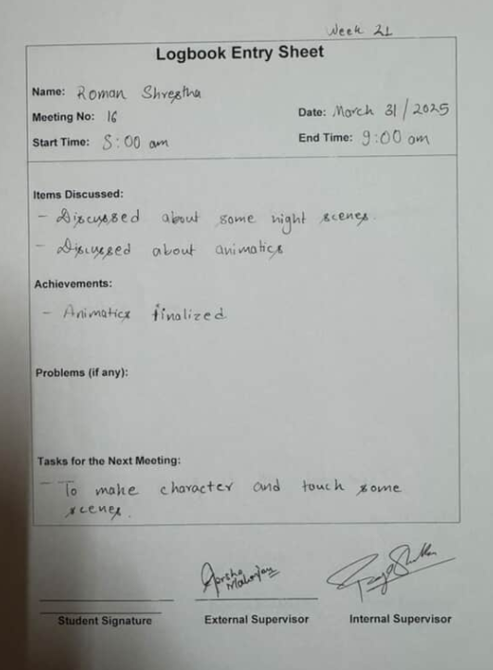

Figure 85 Log sheet 16

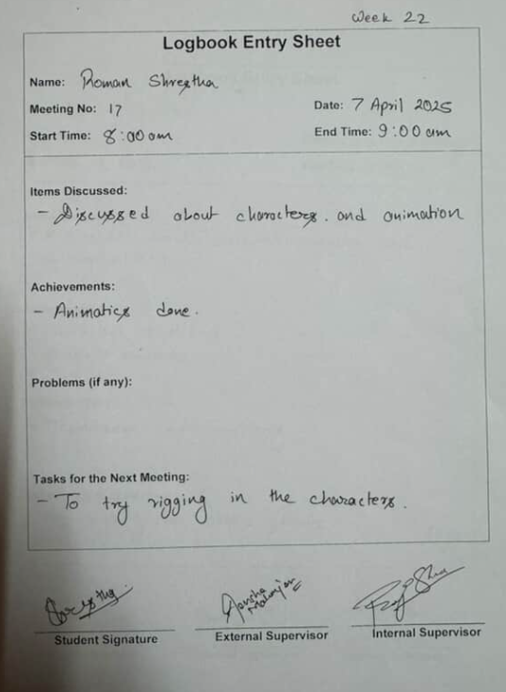

Figure 86 Log sheet 17

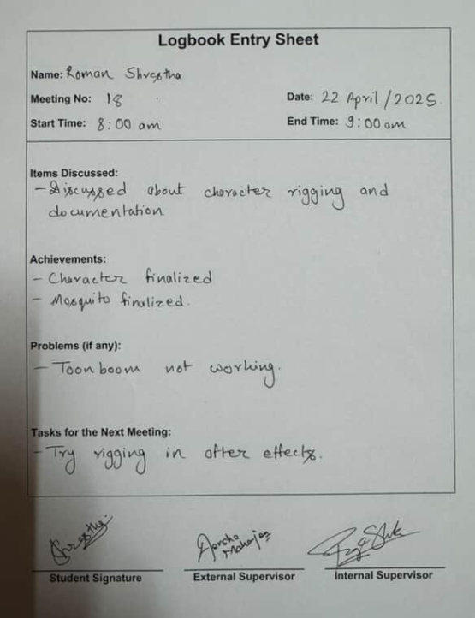

Figure 87 Log sheet 18

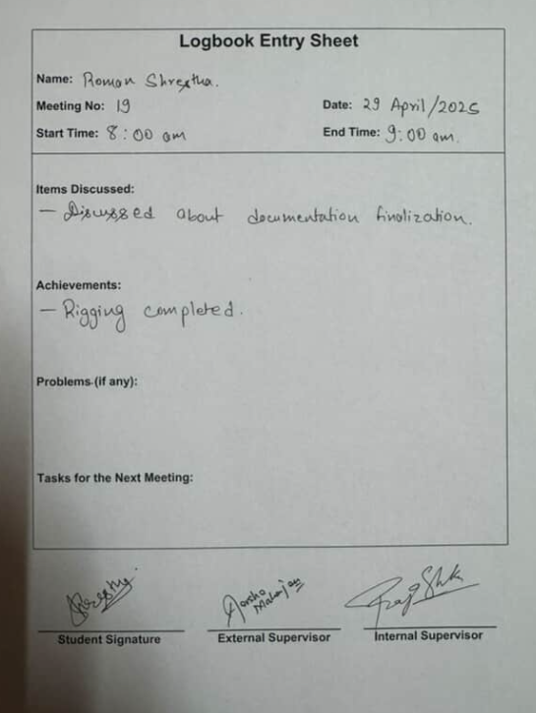

Figure 88 Log sheet 19